CEIS Software MANUAL

Somesh Srivastava

Table of Contents

**Website Features3-5**

Login3

Navigation3

Module Quick Access3

Logout4

Notification Alerts5

Complains5

**Administration6-11**

Departments7

Positions8

Accounts9

Groups10

Document System11

Access Control12

**Project Flow13-46**

Active Project14-31

Project Launch15-19

Project Connect15

Minutes16

Register17

Notes18

Project Documents19

Request19

Schedule Board20-22

Map Accounts23

Map Suppliers24

Map Documents25

Status Boards26-28

Task Board26

Document Board27

Resource Board28

Finance Boards29-31

Budgeting Board29

Tracking Board30

Spending Board31

New Project32-44

Project Create 33

Build Project34-42

Create Tool35-42

Technical36

Schedule37-39

Budget40-41

Financial42

Review Lock42

Project Request43

Project Share44

Project Time Sheet45

My Tasks46

**Skid Builder47 - 53**

Dashboard47

Build Skid48 - 50

Data Manager51

Unit52

Equipment53

*Login*

**Software Features**

Enter Company ID and click ‘Enter’.

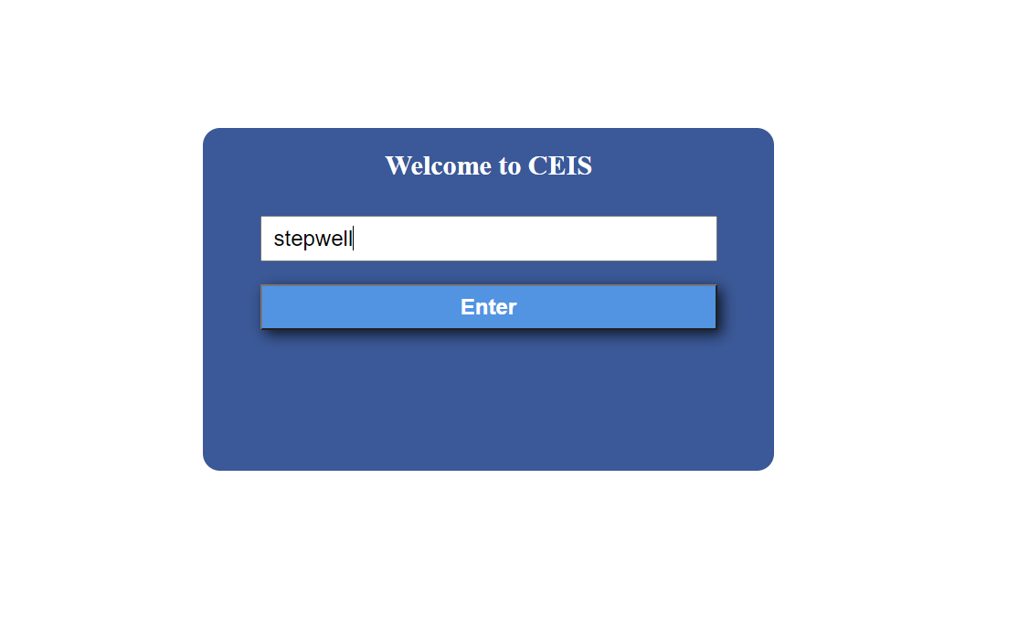

Enter your login credentials then click ‘Enter’.

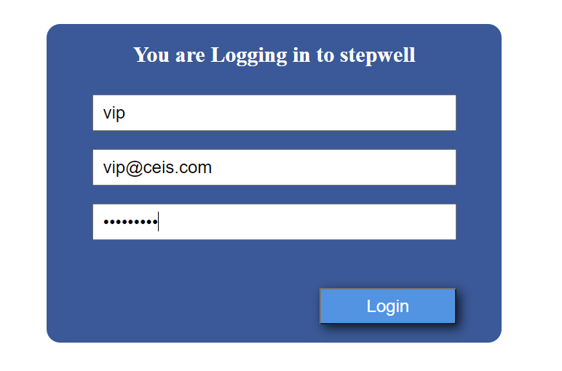

*Logout*

**Software Features**

Click on the  found in the top left corner to log out. You can also logout by clicking  icon located in the top left coner, then click “Logout” button.

*Navigation*

Click  icon to be redirected to the main home page.

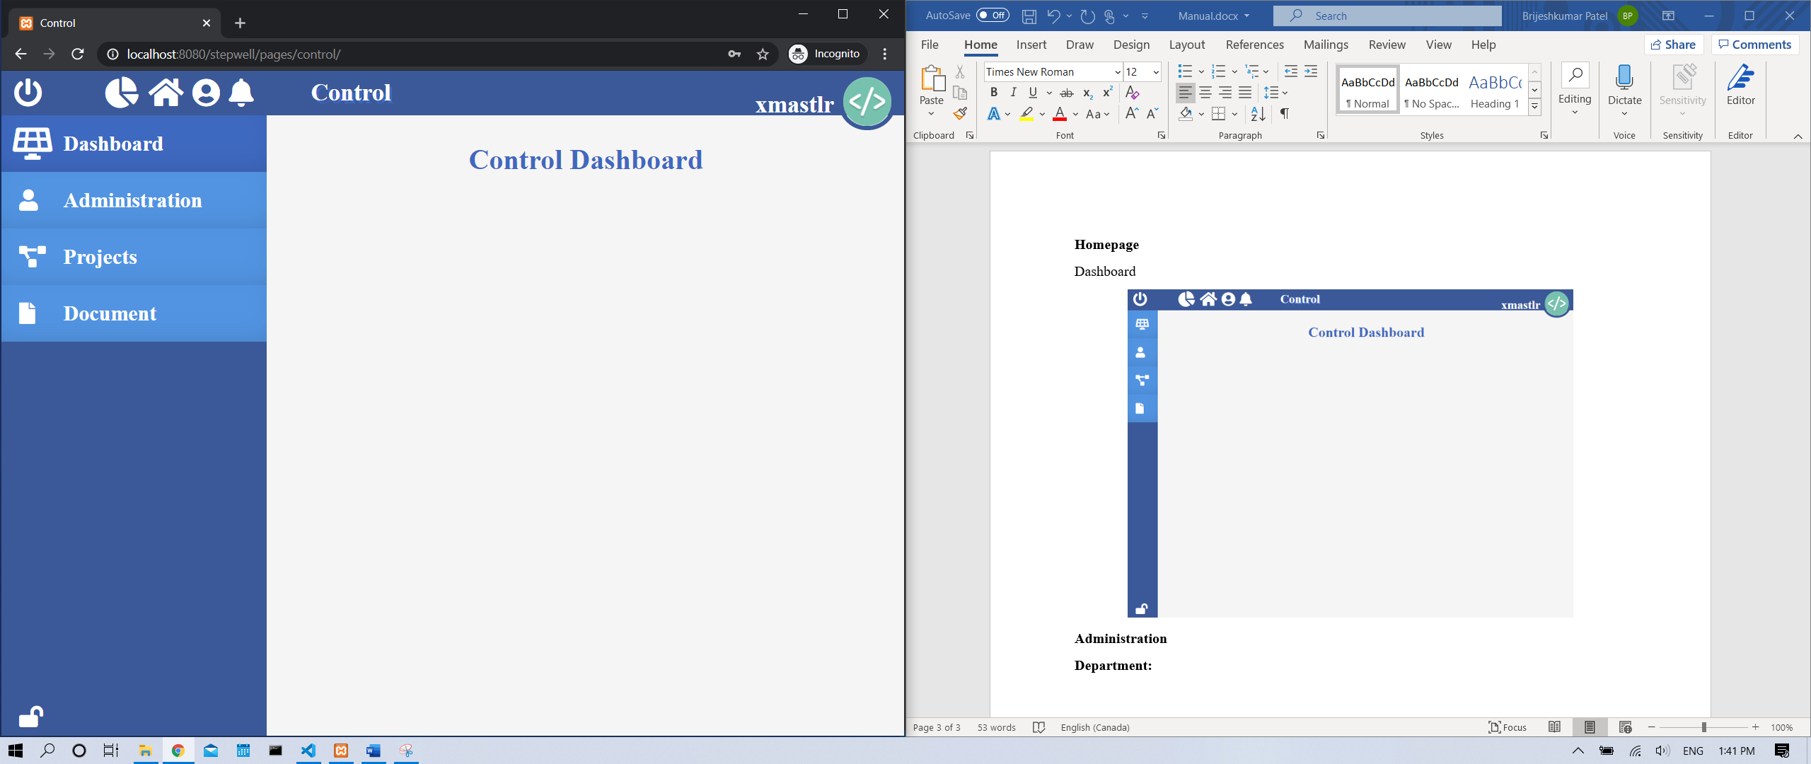

Click  icon to prevent the navigation block found on the left side from expanding when you hover over it.

Click  icon to allow the navigation found on the left side to expand when you hover over it.

*Module Quick Access*

Click on the  found in the top left corner for quick access to various modules.

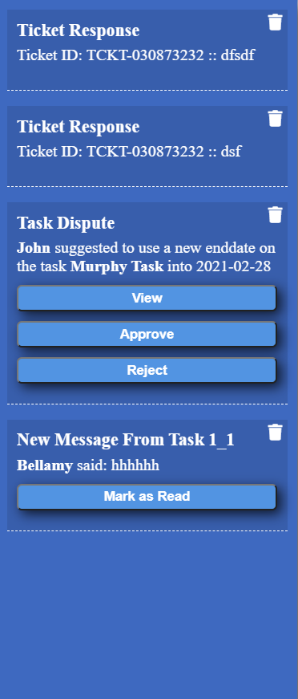*Notification*

**Software Features**

Here you will be able to view all your notifications.

***Note:*** The system will check for a new notification every 30 seconds. To manually fetch for a new notification, you can simply use ‘Refresh Data’ button in and modules.

*Types of Notifications:*

*Information*: Notifications that is only meant to notify you of a change. No action needed.

*View*: Notifications that is only meant to notify you of a change. Clicking on ‘View’ button to redirect you to its designated place.

*Approve/Reject*: Notifications that requires you to approve or reject a request. Click ‘Approve’ button to approve the request. Click ‘Reject’ button to reject the request.

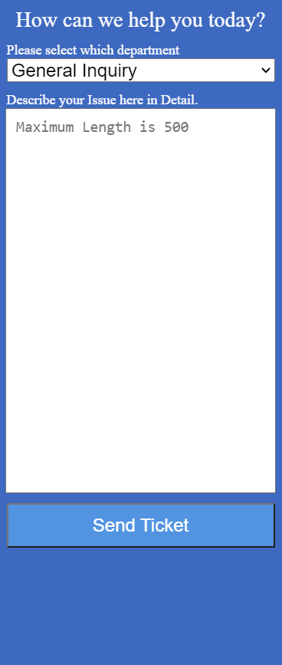*View Notification Alerts:* Click the bell icon found on the top of the page to view all the notification alerts sent to you.

***Complains***

Users can send complains, report bugs, and seek technical assistance through the system.

***Note:*** All the complains are sent to system admin, they will send a reply as soon as possible. All complain replies are notified to user as a notification alert.

*Send Complains:* Click on the  icon, then Select the type of complain/inquiry, then click “Send Ticket” button.

Administration module is a control page where admin can access and alter company’s departments, positions, accounts, group, document system, and maintain control over each user’s access to various modules.

**Administration**

Click  icon to go into Administration module.

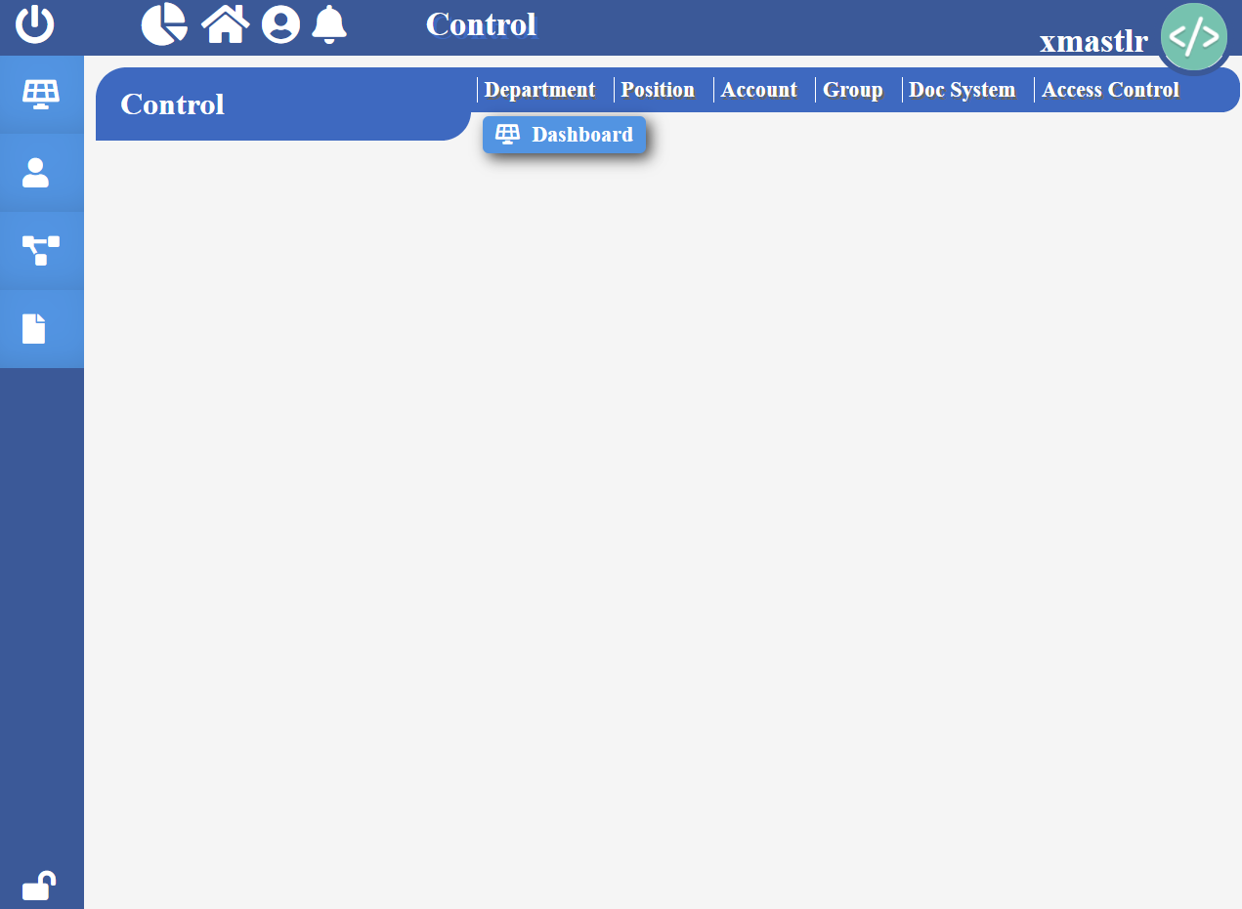

**Department**

**Administration**

To access and update company’s department click “Department” label found at the top of administration module.

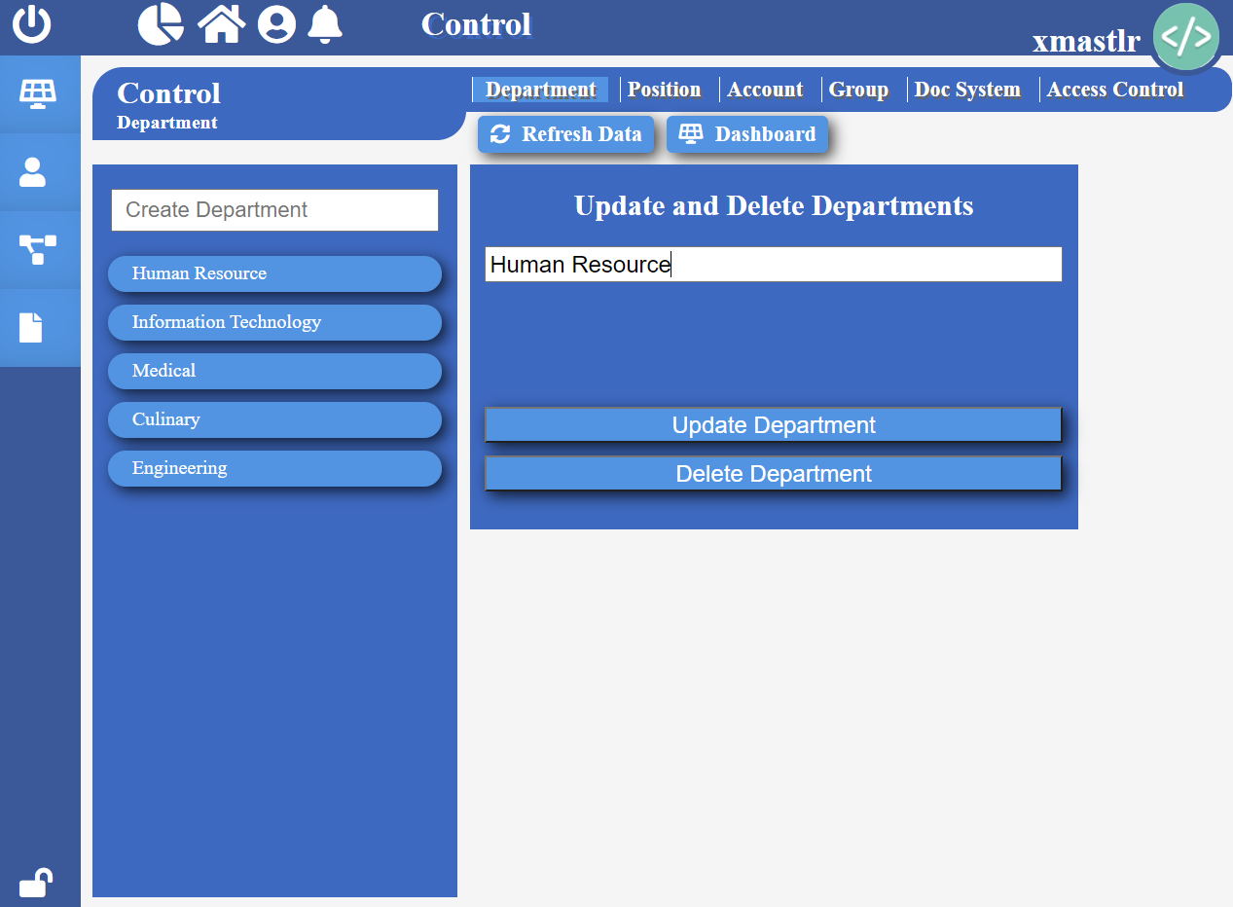

Here you will see a list of company departments that have been already created.

*Create Department:* Type the name of the department in the text field labeled “Create Department” then press Enter on your keyboard.

*Update Department:* Click on the department you wish to update. Change its name then click “Update Department”.

*Delete Department:* Click on the department you wish to delete. Then click “Delete Department”.

*Refresh Data:* Click “Refresh Data” to fetch and show updated company’s departments without having to refresh the web browser.

**Position**

**Administration**

To access and update company’s positions click “Position” label found at the top of administration module.

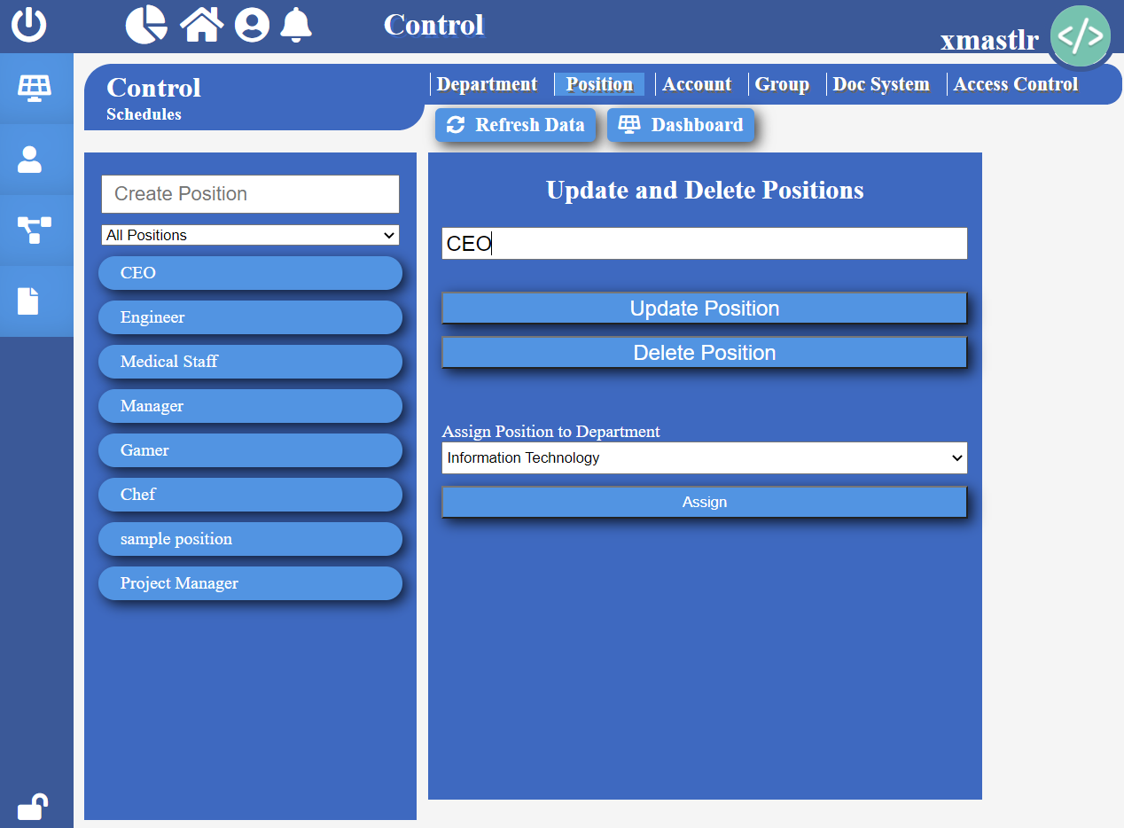

Here you will see a list of company position that have been already created.

You can view positions by department of your choice by simply selecting a department in the select tag named “All Positions”.

*Create Position:* Type the name of the position in the text field labeled “Create Position” then press Enter on your keyboard.

*Update Position:* Click on the position you wish to update. Change its name then click “Update Position”.

*Assign Position:* Click on the position you wish to assign. Then Select a department you want to assign the position to, then click “Assign”.

*Delete Position:* Click on the position you wish to delete. Then click “Delete Position”.

*Refresh Data:* Click “Refresh Data” to fetch and show updated company’s positions without having to refresh the web browser.

**Account**

**Administration**

To access and update company’s accounts click “Account” label found at the top of administration module.

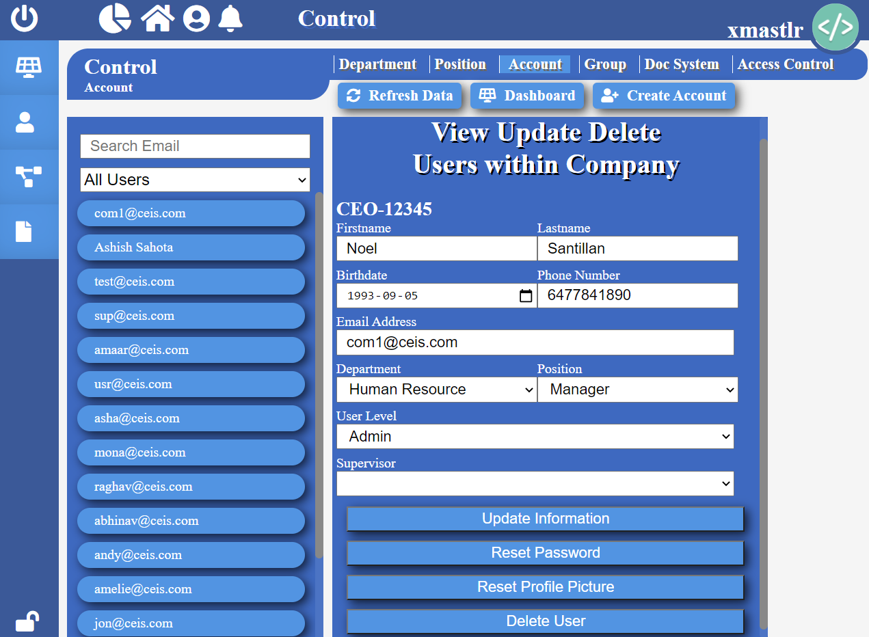

Here you will see a list of company accounts that have been already created.

You can search for your desired account by their email, simply typing their email in the text field labelled “Search Email”.

*Search Account*: You can view accounts by their authority level by simply selecting authority level in the select tag named “All Users”.

*Create Account:* Click “Create Account” button found at the top. Then fill out the requested information, then click “Confirm Create User”.

*Update Account:* Click on the Account you wish to update. Change the information then click “Update Information”.

*Assign Position:* Click on the account you wish to assign position to. Then select a department then a position you want to assign, then click “Update Information”.

*Assign Supervisor:* Click on the account you wish to assign supervisor to. Select a supervisor, then click “Update Information”.

*Refresh Data:* Click “Refresh Data” to fetch and show updated company’s accounts without having to refresh the web browser.

**Group**

**Administration**

To access and update grouped projects click “Group” label found at the top of administration module.

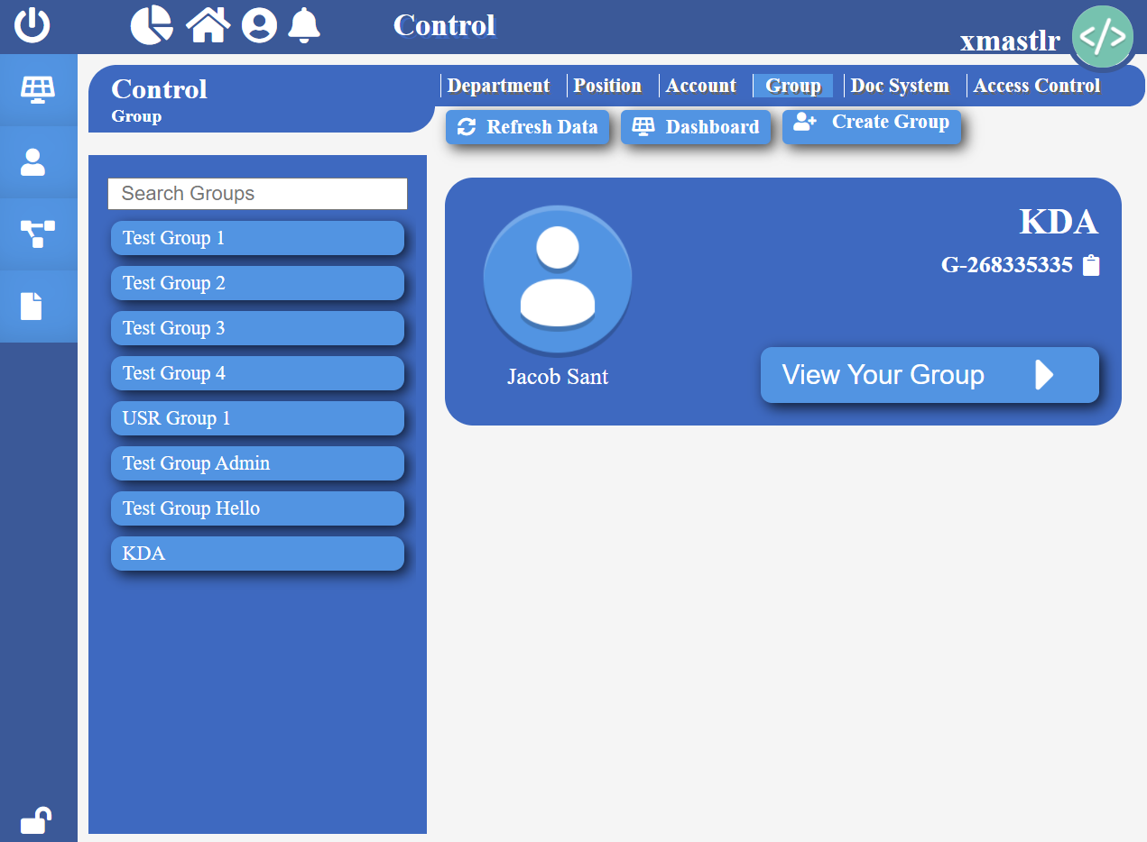

Here you will see a list of grouped projects that have been already created within the company.

*Search Group:* You can search for your desired group by simply typing the name in the text field labelled “Search Groups”.

*Create Group:* Click “Create Group” button found at the top. Then fill out the requested information, then click “Create Group”.

*Delete Group:* Click on the group you wish to delete. Then click “View Your Group”. Then click “Confirm Action”. Click “Close Group” to go back to group main page.

*Add Projects to Group:* Click on the group you wish to add projects to. Then search for the project by its name in the text field labeled “Enter Name”, then click “Search” Then press “Connect” button.

*View Grouped Projects:* Click on the group you desire, then click “View Projects”. Click “Close Group” to go back to group main page.

*Search Group Projects:* Click on the group you desire, then click “View Your Group”. Then you can search by typing the project’s name in the text field labeled “Search Group Projects”. Click “Close Group” to go back to group main page.

*Refresh Data:* Click “Refresh Data” to fetch and show updated company’s Groups and its projects without having to refresh the web browser.

**Document System**

**Administration**

To access and update company’s document categories click “Doc System” label found at the top of administration module.

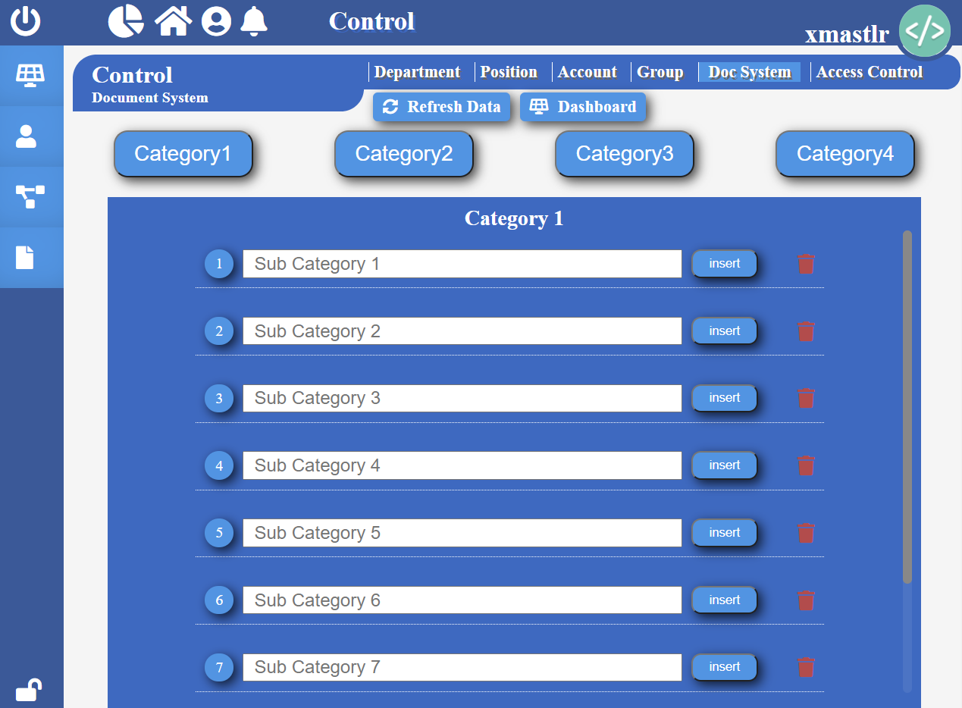

Here you will be able to customize document categories and its subcategories.

*Refresh Data:* Click “Refresh Data” to fetch and show updated document categories and their subcategories without having to refresh the web browser.

**Access Control**

**Administration**

To update user’s access to different modules, click “Access Control” label found at the top of administration module.

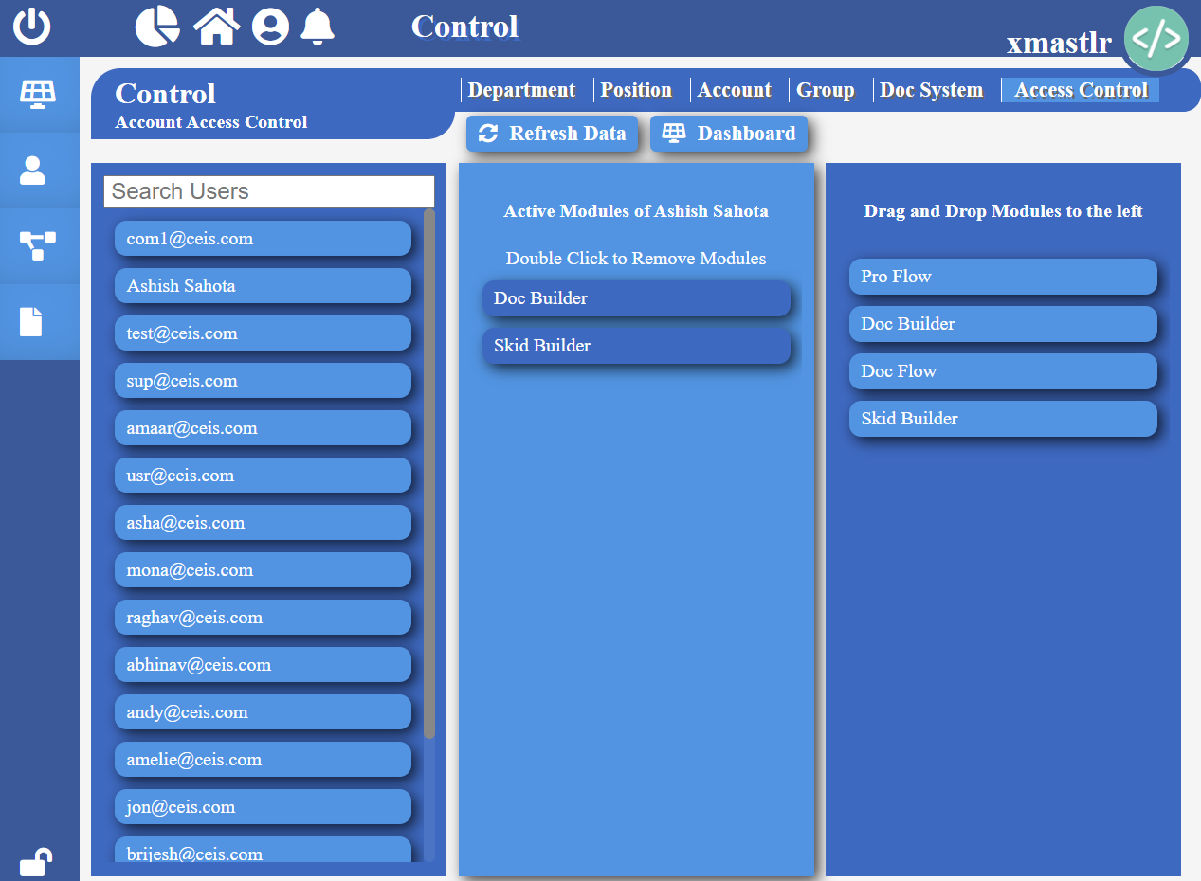

Here you will be able to give access to various module to different users easily.

*Refresh Data:* Click “Refresh Data” to fetch and show updated list of users without having to refresh the web browser.

*Search Users*: You search users by simply typing their email in the text field labelled “Search User”.

*View User’s Access:* Select and click on the user of your choice to view the module they have access to.

*Provide Module Access:* Select and click on the user of your choice then drag and drop module of your choice from right block to centre block.

*Remove Module Access:* Select and click on the user of your choice then drag, then double click on the module you wish to remove in the centre block.

In Pro Flow you will be able to access all the projects in details you are associated with. Here you will be able to create multiple projects, and its related documents and tasks.

**Pro Flow**

To go to pro flow, click  icon.

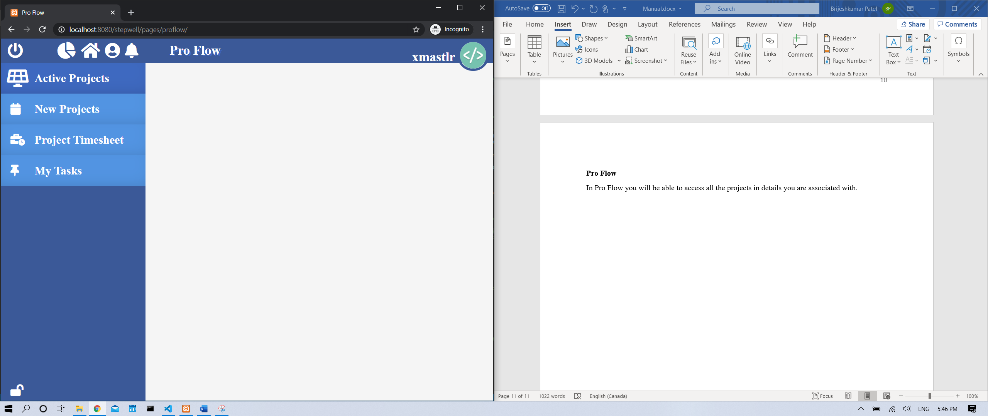

**Active Projects**

**Pro Flow > Active Projects**

Active Projects is a tab on the navigation where users can view their active project’s progress, view project details and more.

**Note:** A project must be set as active to be able to be seen from here.

To get to Active Projects page, click  icon found in the navigation on the left side.

**Dashboard**

Shows brief overview of the project selected. Information shown is as followed:

* Project Name, Project ID
* Owner Name, Owner Photo
* Project Manager Name
* Number of Users, Tasks
* Earliest Start Date
* Estimated Completion Date
* Allocated, Actual, Remaining Hours
* Allocated, Actual, Remaining Budget

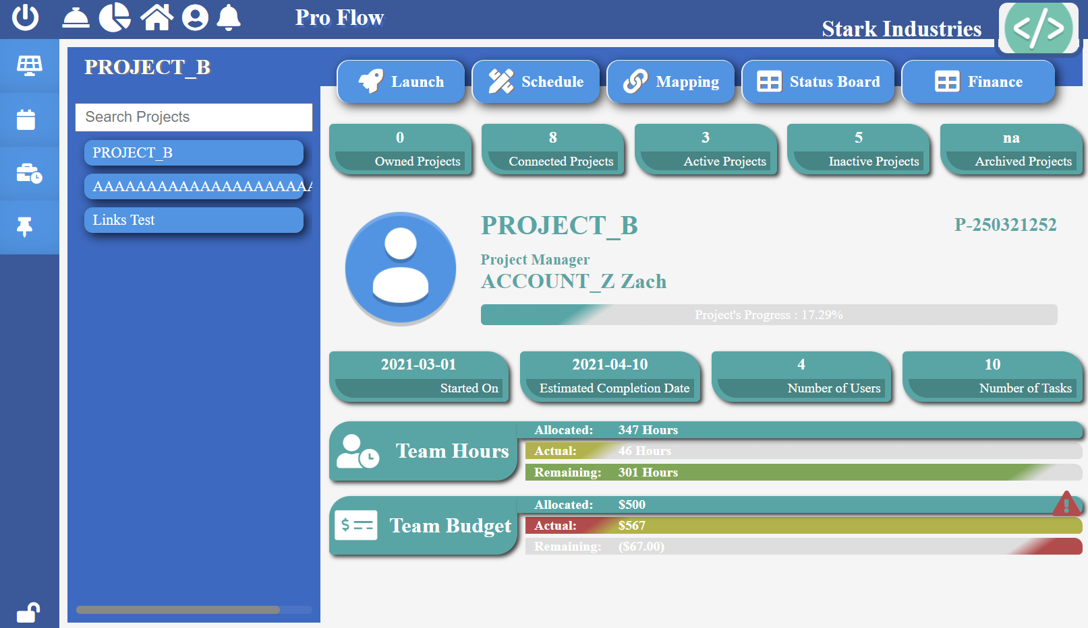

**Project Launch**

**Pro Flow > Active Projects**

To get to project launch, select a project on the Active Project page, then click on the 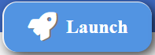 button.

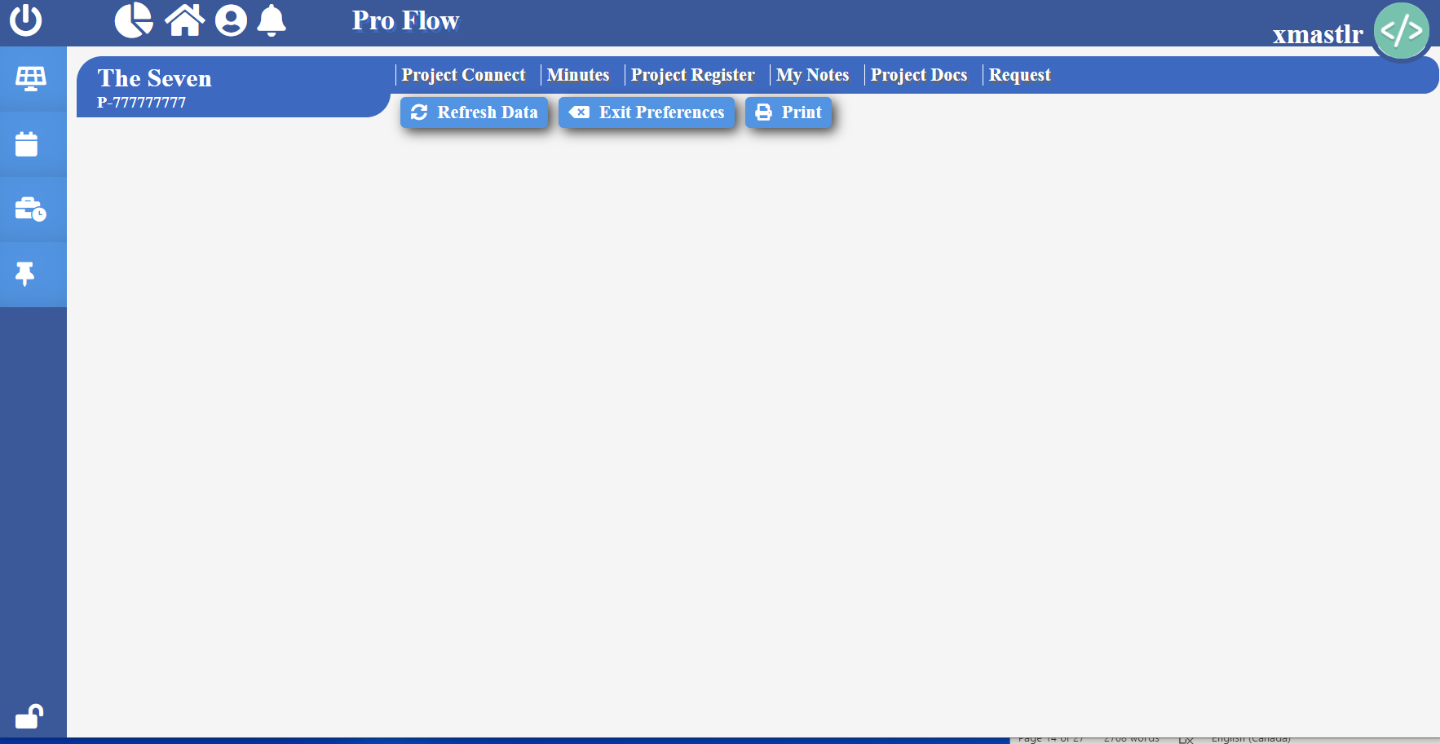

**Project Launch > Project Connect**

To get to active project’s project connect, click “Project Connect” label found on the project launch page.

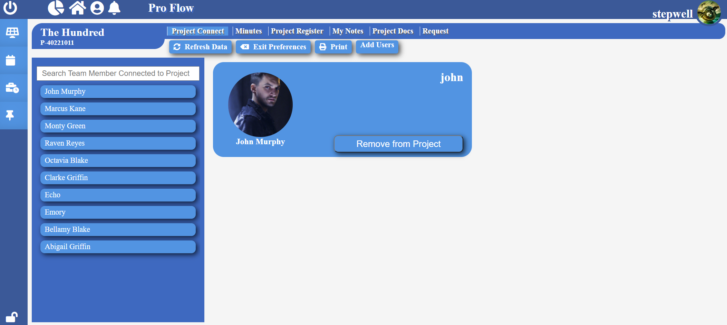 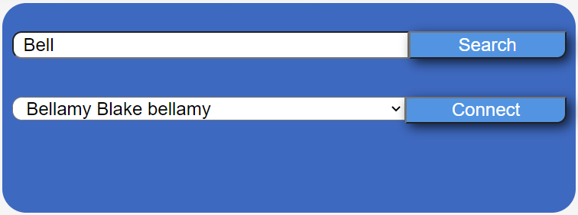

***Search User:***To search user in the project, type the user’s name in the search bar then press enter key from your keyboard.

***Remove User:***To remove user from the project, select the user you want to remove, then click “Remove from Project” button.

***Add New Users:***To add new users to the project, simply click the “Add User” button found on the Project Connect page. Search for user to be added and then click “Connect” button.

**Project Launch > Project Minutes**

**Pro Flow > Active Projects**

To get to active project’s project minutes, click “Project Minutes” label found on the project launch page.

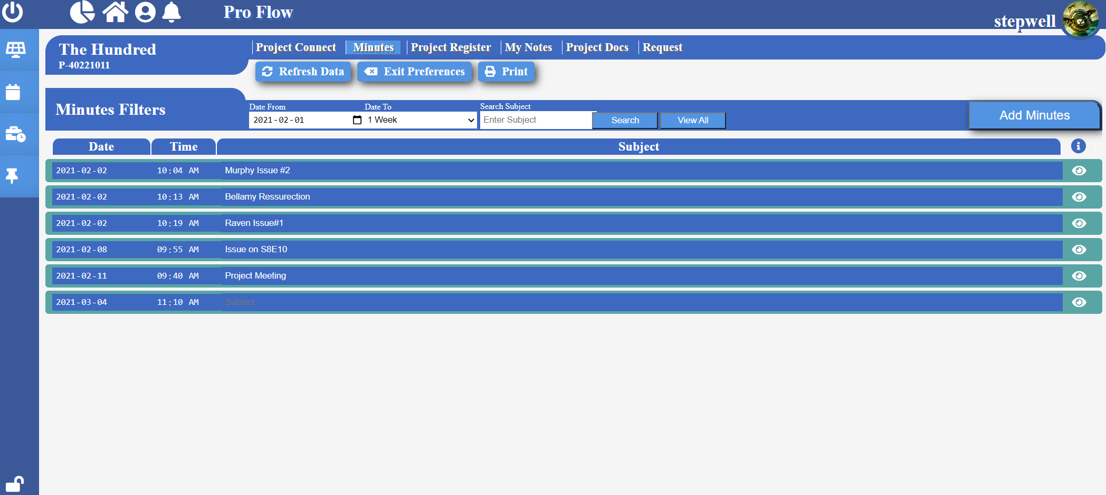

***Search Minutes:***To search minutes, type the subject you want to look for in the “Enter Subject” field located on the top. Select the approximate date range, then click “Search” button to retrieve minutes.

***View All Minutes:***To view all minutes, click on the “View All” button.

***View Minutes in Details:***Click  icon on the minute line you want to view in detail. Then click  icon to exit the detailed view.

*Remove Minutes:* Click  icon on the minute line you want to view in detail. Then click  icon to remove that minute entry.

*Add Minutes:* Click “Add Minutes” button located on the top. Fill necessary information, then click “Add Minutes” button. Then choose the type of entry and enter entry description. Then click “Save Minutes” button to save.

**Note:** There are 4 types of entries that can be recorded: I – Information, C – Change, D – Decision, A – Action.

**Note:** For type of entry “A” (Action), type of resources selected will be assigned the task once the entry has been successfully recorded. Entry “I” will be recorded and accessible from “My Notes” tab in “Project Launch” page. Entry “C” and “D” will be recorded and accessible from “Project Register” tab in “Project Launch” page.

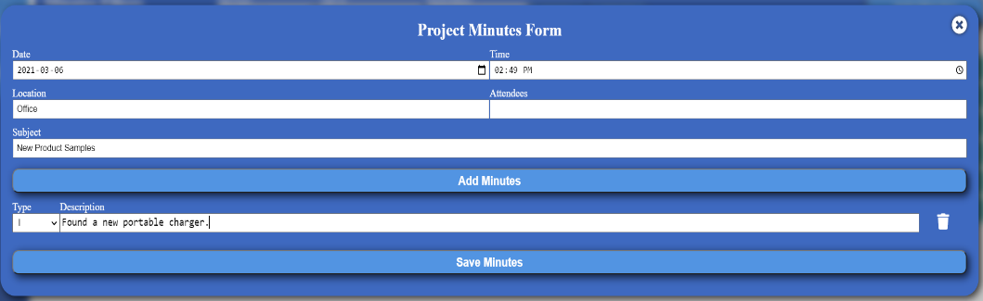

**Project Launch > Project Register**

**Pro Flow > Active Projects**

To get to active project’s project minutes, click “Project Minutes” label found on the project launch page.

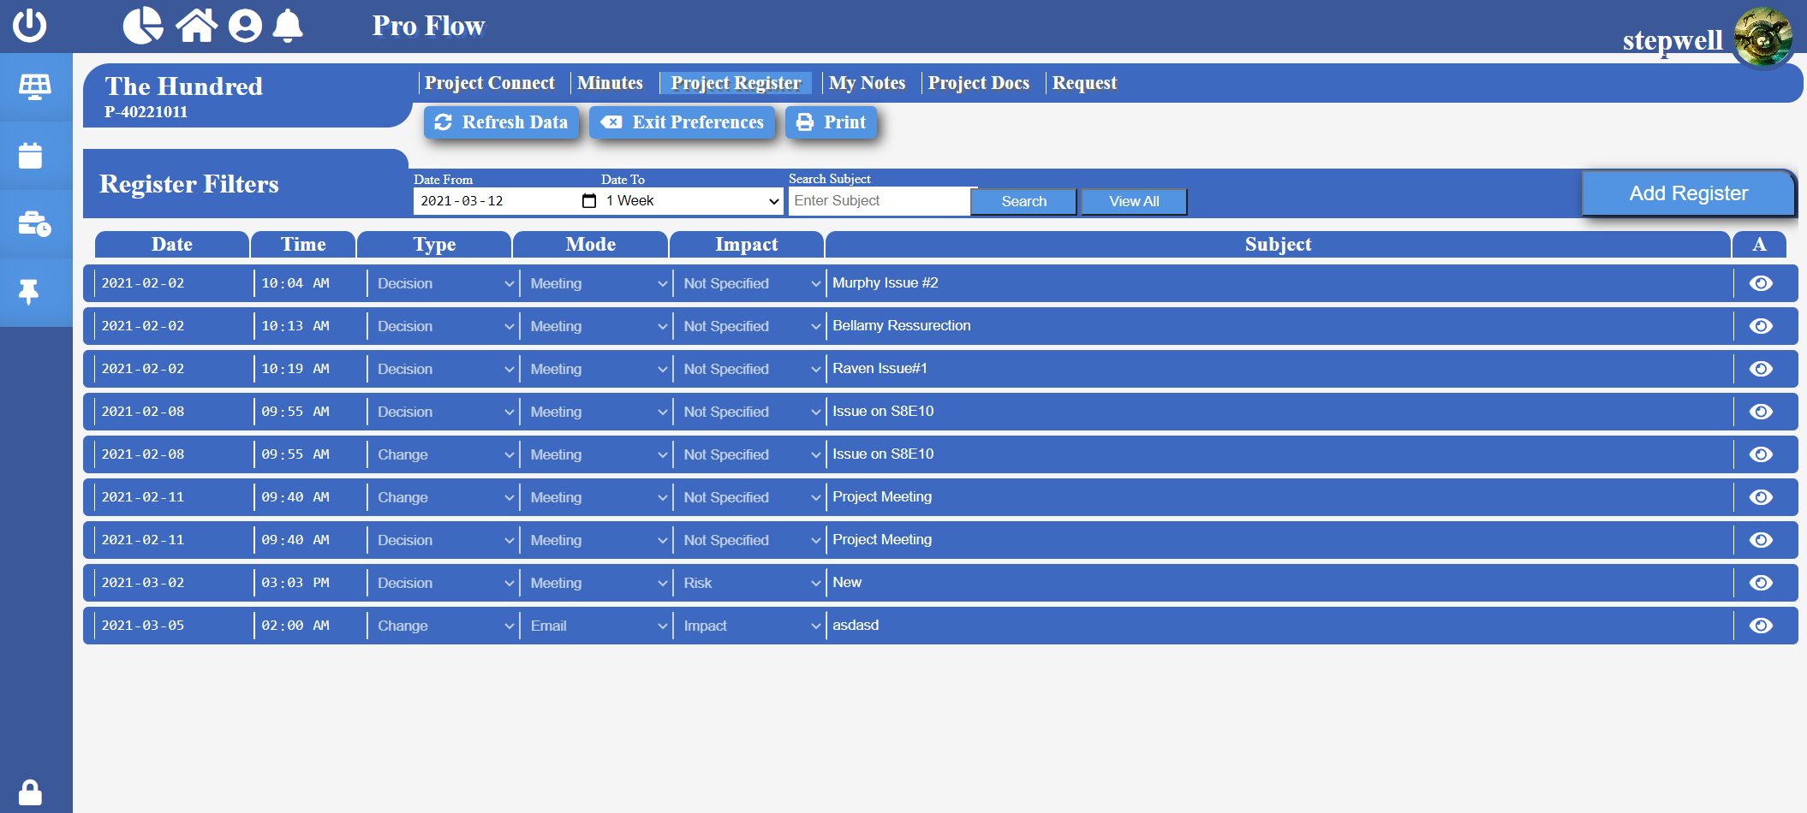

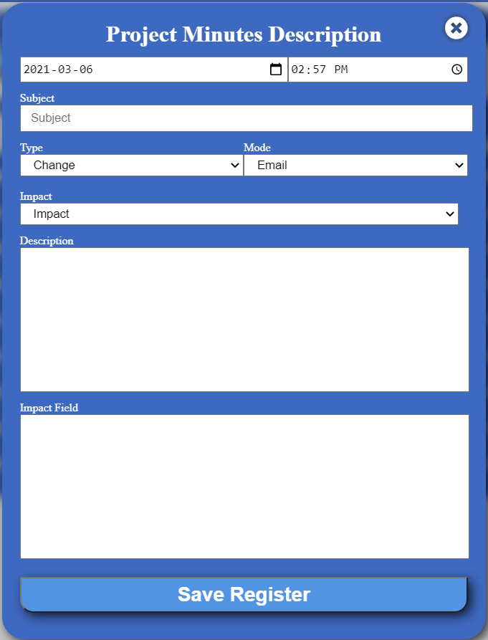*Search Register by Subject:* To search register, type the subject you want to look for in the “Enter Subject” field located on the top. Select the approximate date range, then click “Search” button to retrieve project register.

*View All Registers:* To view all registers, click on the “View All” button.

*View Register in Details:* Click  icon on the register line you want to view in detail. Then click  icon to exit the detailed view.

*Remove Register:* Click  icon on the register line you want to view in detail. Then click “Delete Register” remove that register entry.

*Add Register:* Click “Add Register” button located on the top. Fill necessary information, then click “Save Register” button.

**Project Launch > My Notes**

**Pro Flow > Active Projects**

To get to active project’s my notes, click “My Notes” label found on the project launch page.

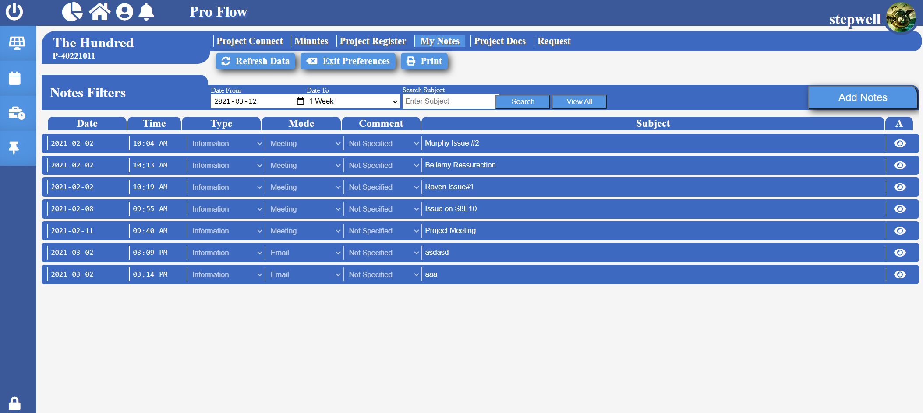

**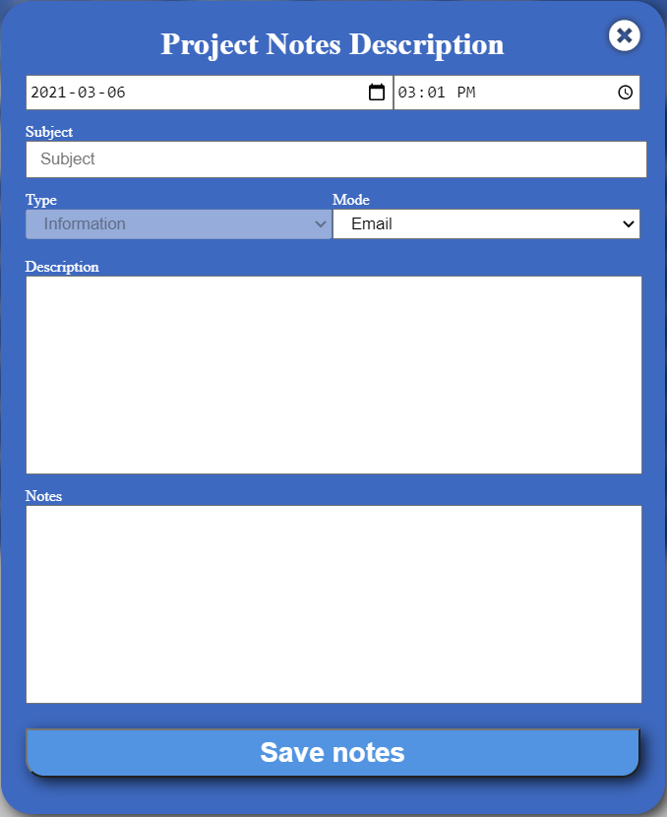*Search Notes by Subject:***To search notes, type the subject you want to look for in the “Enter Subject” field located on the top. Select the approximate date range, then click “Search” button to retrieve notes.

***View All Notes:***To view all notes, click on the “View All” button.

***View Notes in Details:***Click  icon on the note you want to view in detail. Then click  icon to exit the detailed view.

***Remove Note:***Click  icon on the register line you want to view in detail. Then click “Delete Notes” remove that note entry.

***Add Note:***Click “Add Notes” button located on the top. Fill necessary information, then click “Save Notes” button.

**Project Launch > Project Docs**

**Pro Flow > Active Projects**

To get to active project’s project docs, click “Project Docs” label found on the project launch page.

***Search Connected Documents:***To search documents in the project, type the document name in the search bar then press ‘enter’ key from your keyboard.

**Project Launch > Project Request**

To get to active project’s Request tab, click “Request” label found on the project launch page.

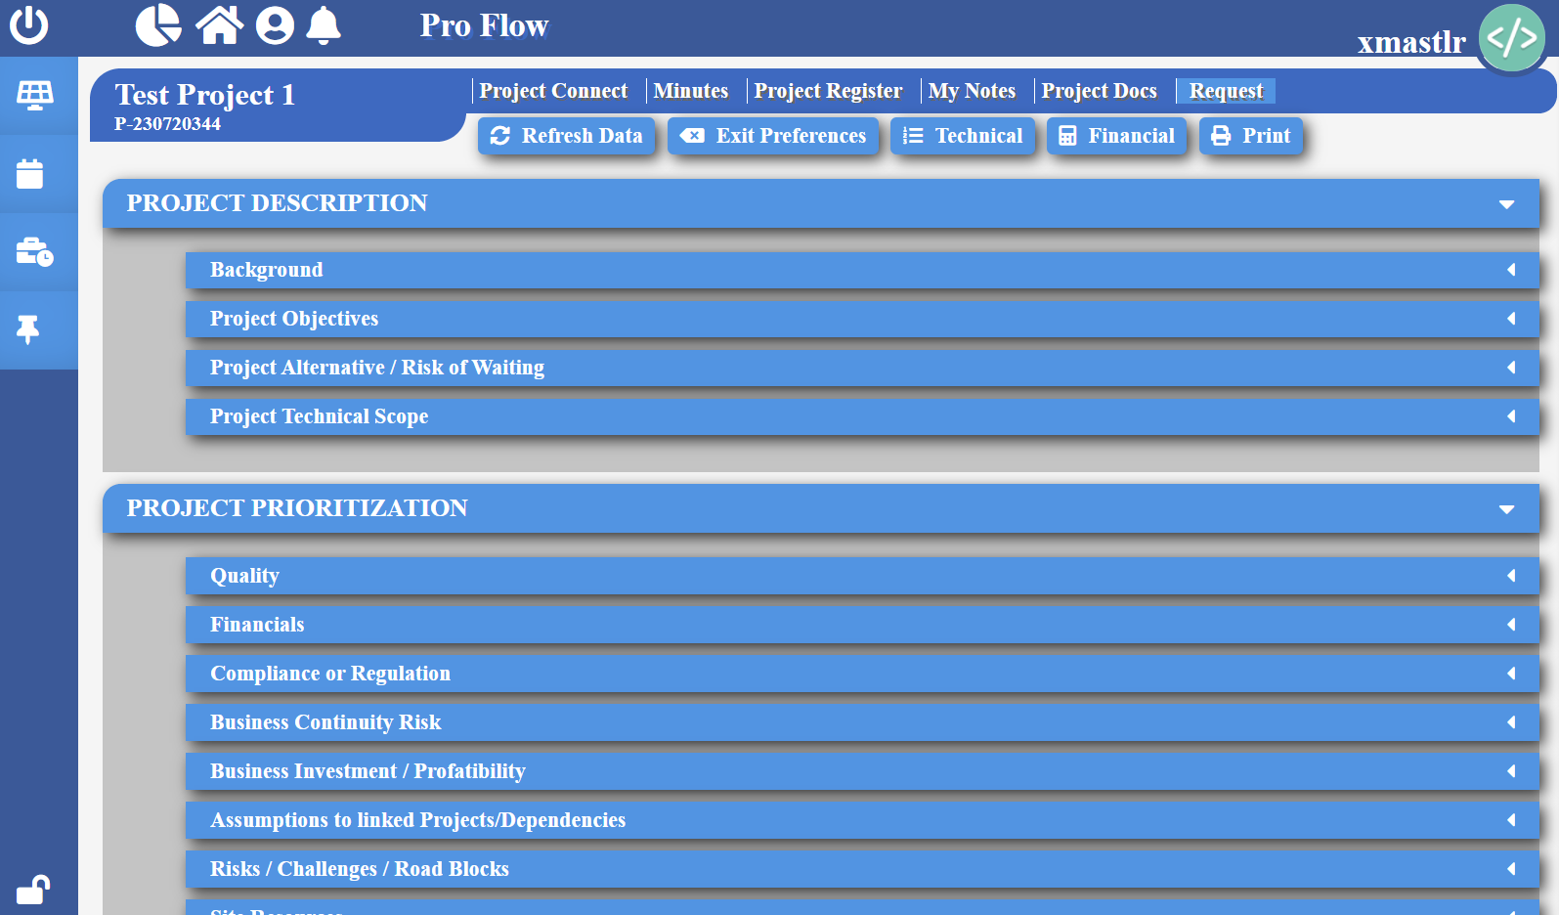

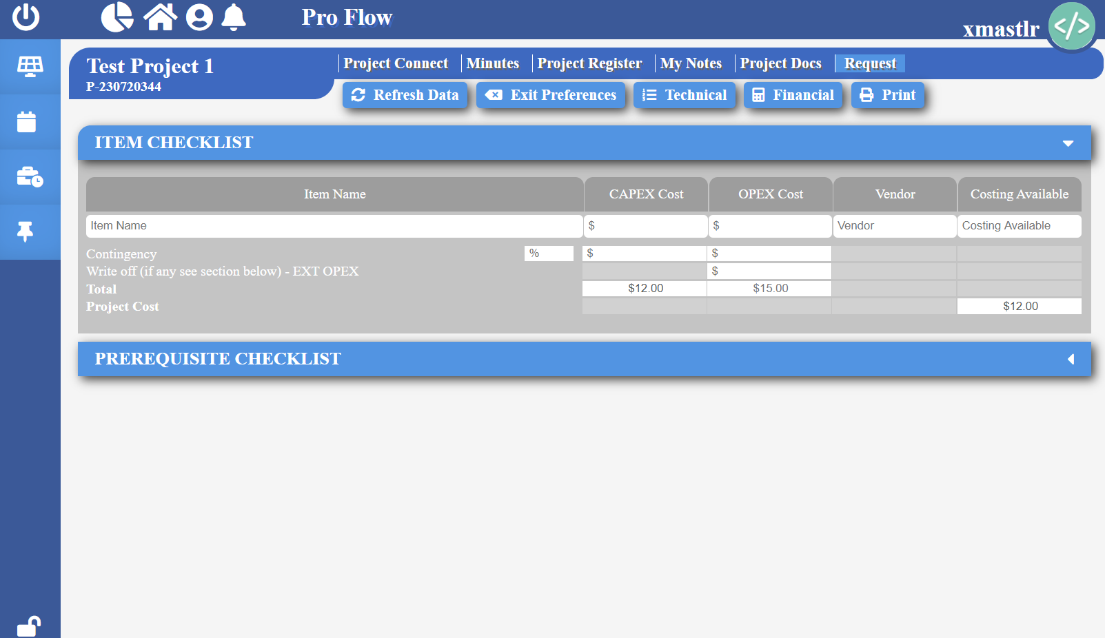

***View Technical:***Click  button found on the header on the top to view all the technical details about the project that was approved.

***View Financial:***Click  button found on the header on the top to view all the financial details about the project.

**Schedule Board**

**Pro Flow > Active Projects**

To create a project schedule, click “Schedule” tab found on the top of the create tool.

**Note:** Schedule Board is only accessible by project managers and supervisors.

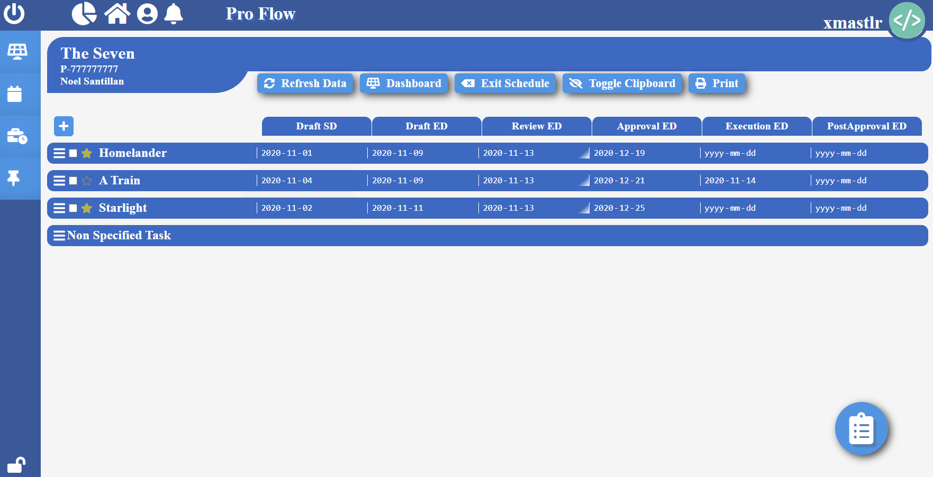

*Create Planning Document:* To create a document plan, click  icon, and fill the require information and then click “Save”. Press “Cancel” to discard document creation.

*Remove Planning Documents:* Click  checkbox for the documents you wish to remove, then click  icon.

*Edit Planning Documents:* Click  checkbox for the documents you wish to edit. Click  icon, make necessary changes then click  icon to save changes.

*View Linked Documents:* Click  checkbox for the document you wish to view links, then click  icon.

*Add Link:* Click  checkbox for the document you wish to link documents to, then click  icon. Select a document stage, then click “Select Stage” button. Then select the document name you wish to link, then click “Add Link” button.

*Remove Linked Document:* Click  checkbox for the any linked document besides the one you want to remove, then click  icon. Then, click  icon on the document you wish to remove from link.

*View Predecessor Documents:* Click  checkbox for the document you wish to view predecessors, then click  icon.

**Pro Flow > Active Projects**

*Add Predecessor:* Click  checkbox for the document you wish to add predecessor, then click  icon. Select a document stage, then click “Select Stage” button. Then select the document name you wish add predecessor as, then click “Add Predecessor” button.

*Remove Predecessor Document:* Click  checkbox for the document you want to remove predecessor from, then click  icon. Then, click  icon on the document you wish to remove.

*View Tasks:* Click on the name of the document whose tasks you want to view.

*Create Task:* Click on the name of the document that you want to create the task under. Then click  icon, then fill its necessary information.

*Edit Task:* Click on the name of the document that the task falls under. Then click  icon for the task, then update the information, then click  icon to save the changed information.

*Remove Task:* Click on the name of the document that the task falls under. Then click  icon to remove the task.

*Add Hourly Resource:* Click on the name of the document that the task falls under. Then click  icon for the task you want to add resource to. Then select “Hourly” as the type of resource, then select the user’s name, assign hours then click “Add Resource” button to complete.

*Add Supplier Resource:* Click on the name of the document that the task falls under. Then click  icon for the task you want to add resource to. Then select “Supplier” as the type of resource, then select the supplier’s name, then click “Add Resource” button to complete.

*Add T&M Resource:* Click on the name of the document that the task falls under. Then click  icon for the task you want to add resource to. Then select “T&M” as the type of resource, then select the user’s name, assign hours then click “Add Resource” button to complete.

*Create Temporary Resource:* Click on the name of the document that the task falls under. Then click  icon for the task you want to add resource to. Then select the type of resource, then write the temporary resource name, then click “Create”.

*Edit Resource:* Click on the name of the document that the task falls under. Then click  icon for the task you want to remove resource from. Click  icon on the resource you wish to edit, make necessary changes then click  icon to save changes.

*Remove Resource:* Click on the name of the document that the task falls under. Then click  icon for the task you want to remove resource from. Click  icon on the resource you wish to remove.

**Pro Flow > Active Projects**

*Set Milestone:* Click icon on the document you desire to set as milestone.

*Remove Milestone:* Click icon on the document you desire to remove from milestone.

**Map Accounts**

**Pro Flow > Active Projects**

You can map temporary users with an actual company user in the Map Accounts page. To get to Map Accounts page, select the project you want to map accounts under found on the Active Projects page, then click “Map Docs” tab on the top of the page. Then select  tab on the top.

**Note:** Map Accounts is only accessible by project managers and supervisors.

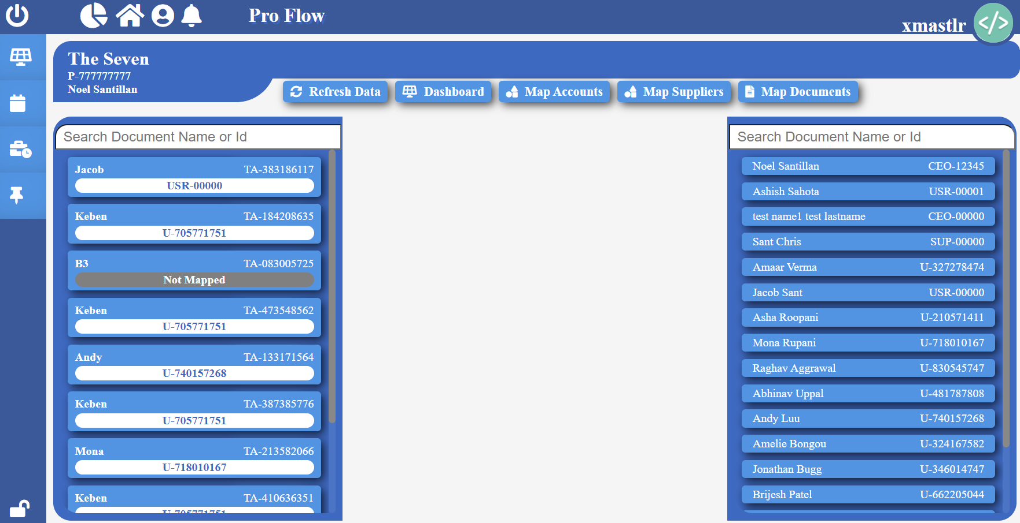

*Map Users:* Simply drag the temporary account from the right side and drop into an actual company user on the left side.

**Note:** Mapping temporary account with actual account will update and assign any project related details to the actual user.

**Map Suppliers**

**Pro Flow > Active Projects**

You can map temporary suppliers with an actual company supplier in the Map Suppliers page. To get to Map Supplier page, select the project you want to map suppliers under found on the Active Projects page, then click “Map Docs” tab on the top of the page. Then select  tab on the top.

**Note:** Map Suppliers is only accessible by project managers and supervisors.

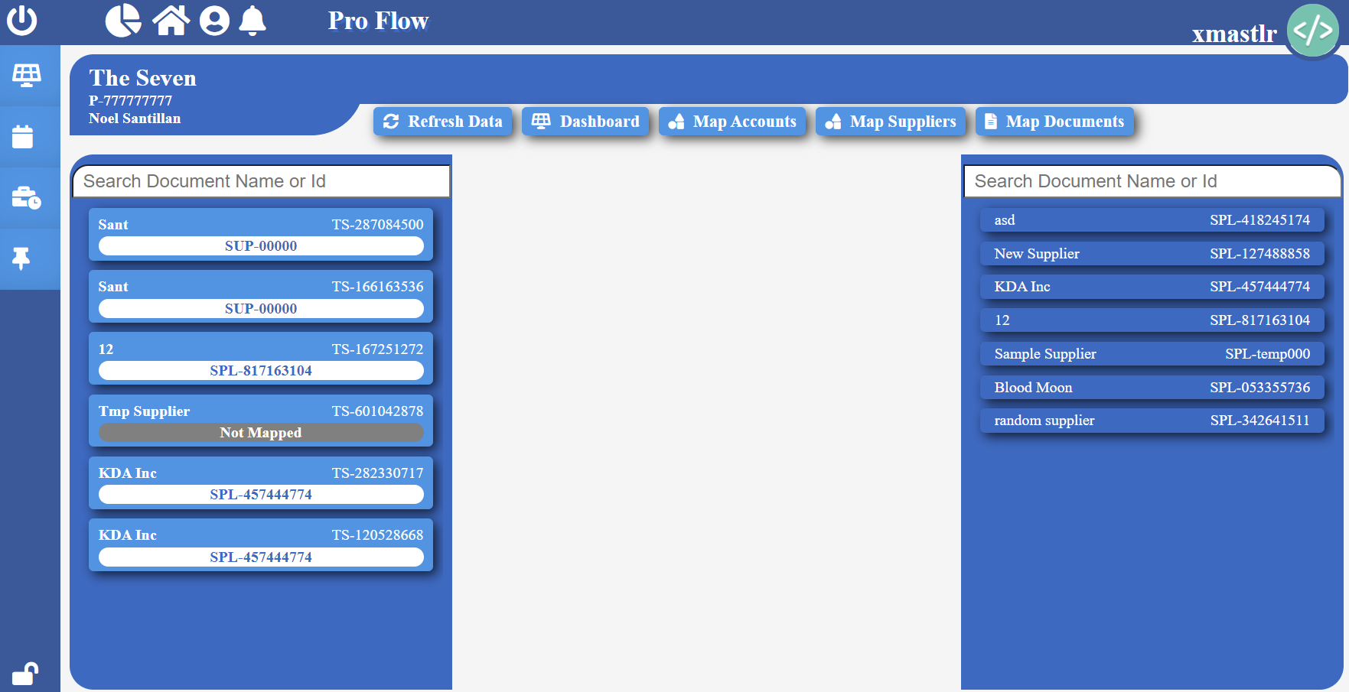

*Map Suppliers:* Simply drag the temporary supplier from the right side and drop into an actual company supplier on the left side.

**Note:** Mapping temporary supplier with actual supplier will update and assign any project related details to the actual supplier.

**Map Documents**

**Pro Flow > Active Projects**

You can assign documents to a selected company user in the Map Documents page. To get to Map Documents page, select the project you want to map document under, found on the Active Projects page, then click “Map Docs” tab on the top of the page. Then select  tab on the top.

**Note:** Map Documents is only accessible by project managers and supervisors.

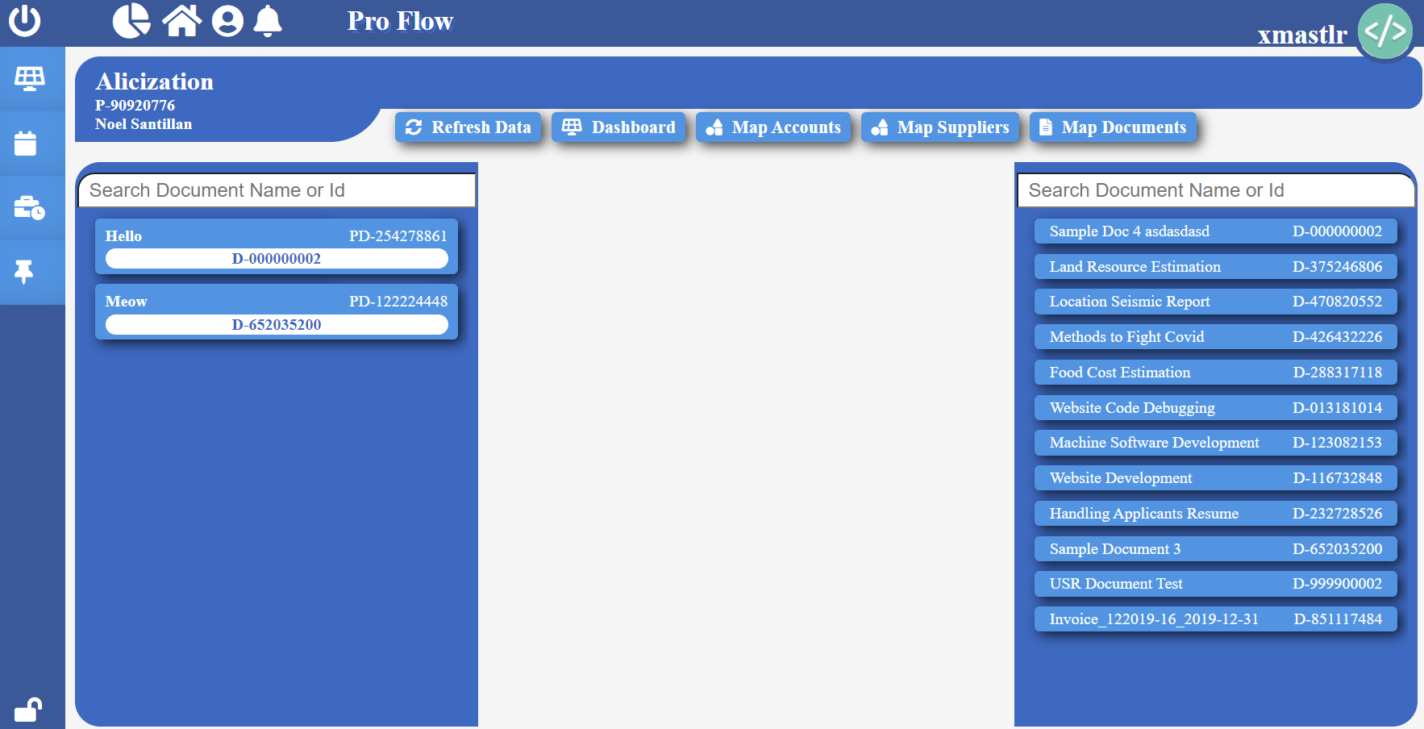

*Map Document:* Simply drag the company user from the right side and drop into project document on the left side.

**Note:** Mapping user to a document will assign the user to the document and update user’s name for the document.

**Task Board**

**Pro Flow > Active Projects**

To get to task board, select a project, found on the Active Projects page, then click “Status Board” tab on the top of the page. Then click on “Task” option from the drop-down list.

**Note:** Task Board is only accessible by project managers and supervisors.

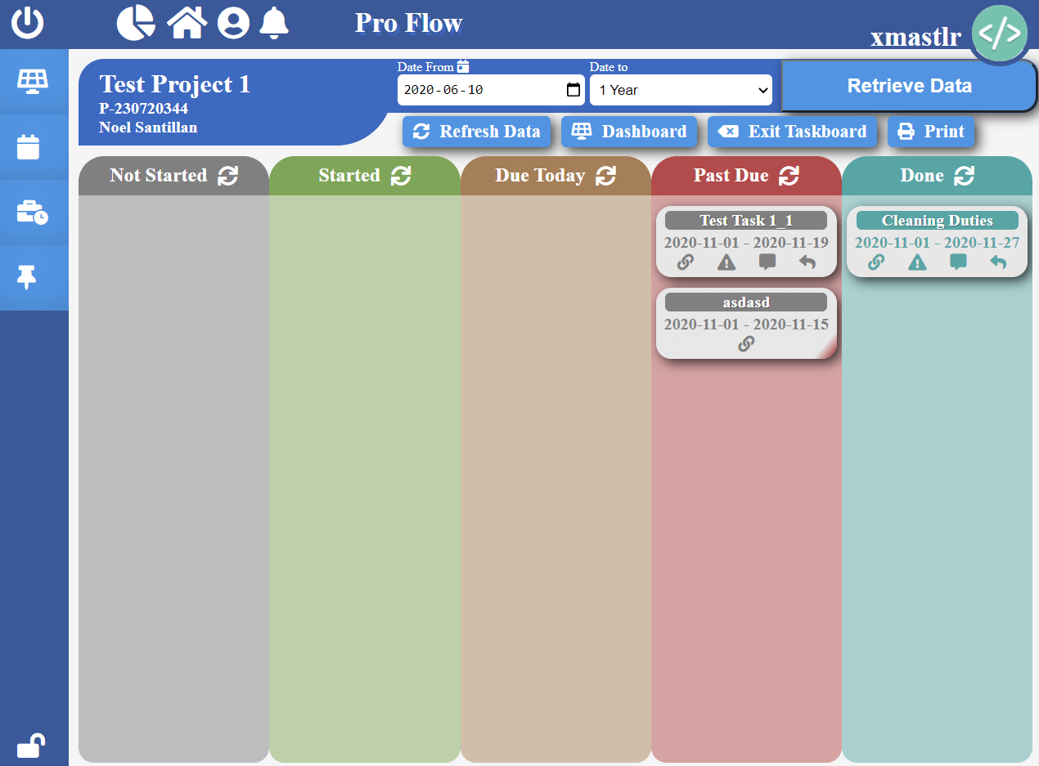

*View Project Tasks:* In the task board, select the time from you want to view, by selecting from and to date, then click “Retrieve Data”.

*View Task Owner:* In the task board, hover over  icon on the task of your choice to the owner of the task.

*View Disputes:* In the task board, click  icon on the task of your choice to view any disputes for the task.

*View Team Message:* In the task board, click  icon on the task of your choice to view any team messages for the task.

*Send Team Message:* In the task board, click  icon on the task of your choice. Write a message for the team in the given text field and click “Send” button.

**Document Board**

**Pro Flow > Active Projects**

To get to document board, select a project, found on the Active Projects page, then click “Status Board” tab on the top of the page. Then click on “Document” option from the drop-down list.

**Note:** Document Board is only accessible by project managers and supervisors.



*View Project Planning Documents:* In the document board, select the time from you want to view, by selecting from and to date, select the filter you wish to sort documents by and select “Planning” as the type of documents, then click “Retrieve Documents”.

*View Project Active Documents:* In the document board, select the time from you want to view, by selecting from and to date, select the filter you wish to sort documents by and select “Actual” as the type of documents, then click “Retrieve Documents”.

**Note:** Documents will be color coded to indicate whether document stage was completed within the scheduled deadline. Green means on time. Yellow means due today. Red means overdue.

*View Linked Documents:* In the document board, hover over  icon on the document of your choice to view all linked documents.

*View Document ID:* Click  icon to view document ID. Click  icon again to go back to viewing document name.

**Resource Board**

**Pro Flow > Active Projects**

To get to resource board, select a project, found on the Active Projects page, then click “Status Board” tab on the top of the page. Then click on “Resource” option from the drop-down list.

**Note:** Resource Board is only accessible by project managers and supervisors.

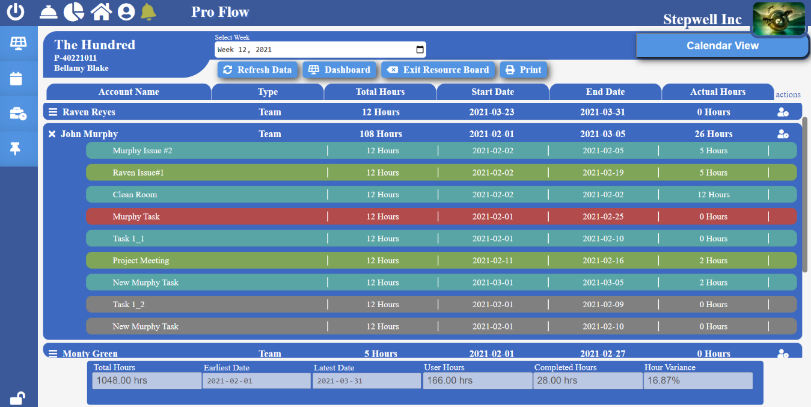

*View Project Resources:* In the resource board, all the resources will be listed by default.

*View Tasks assigned to Resource:* In the resource board, click  icon to expand and view all the tasks assigned to a resource. Click  icon to collapse and minimize the tasks view.

*Weekly Calendar View:* Select a week of your choice, then click “Calendar View” button.

*Resource View:* Select “Resourceboard” button to view all the resources working on the project.

**Budgeting Board**

**Pro Flow > Active Projects**

To get to budgeting board, select a project, found on the Active Projects page, then click “Finance” tab on the top of the page. Then click on “Budgeting” option from the drop-down list.

**Note:** Budgeting Board is only accessible by project managers and supervisors.

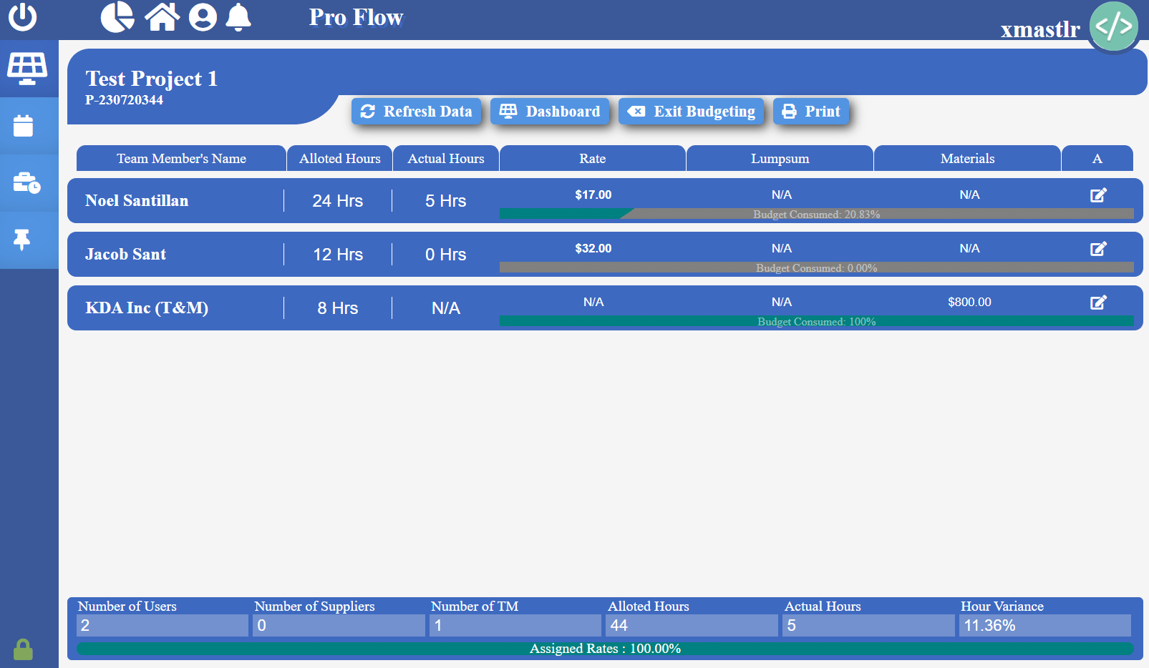

*View Resource Budget:* In the budgeting board, all the resources will be listed by default.

*Update Resource Rate:* In the budgeting board, click  icon, change the rate for the resource then click  icon to save changes.

**Tracking Board**

**Pro Flow > Active Projects**

To get to tracking board, select a project, found on the Active Projects page, then click “Finance” tab on the top of the page. Then click on “Tracking” option from the drop-down list.

**Note:** Tracking Board is only accessible by project managers and supervisors.

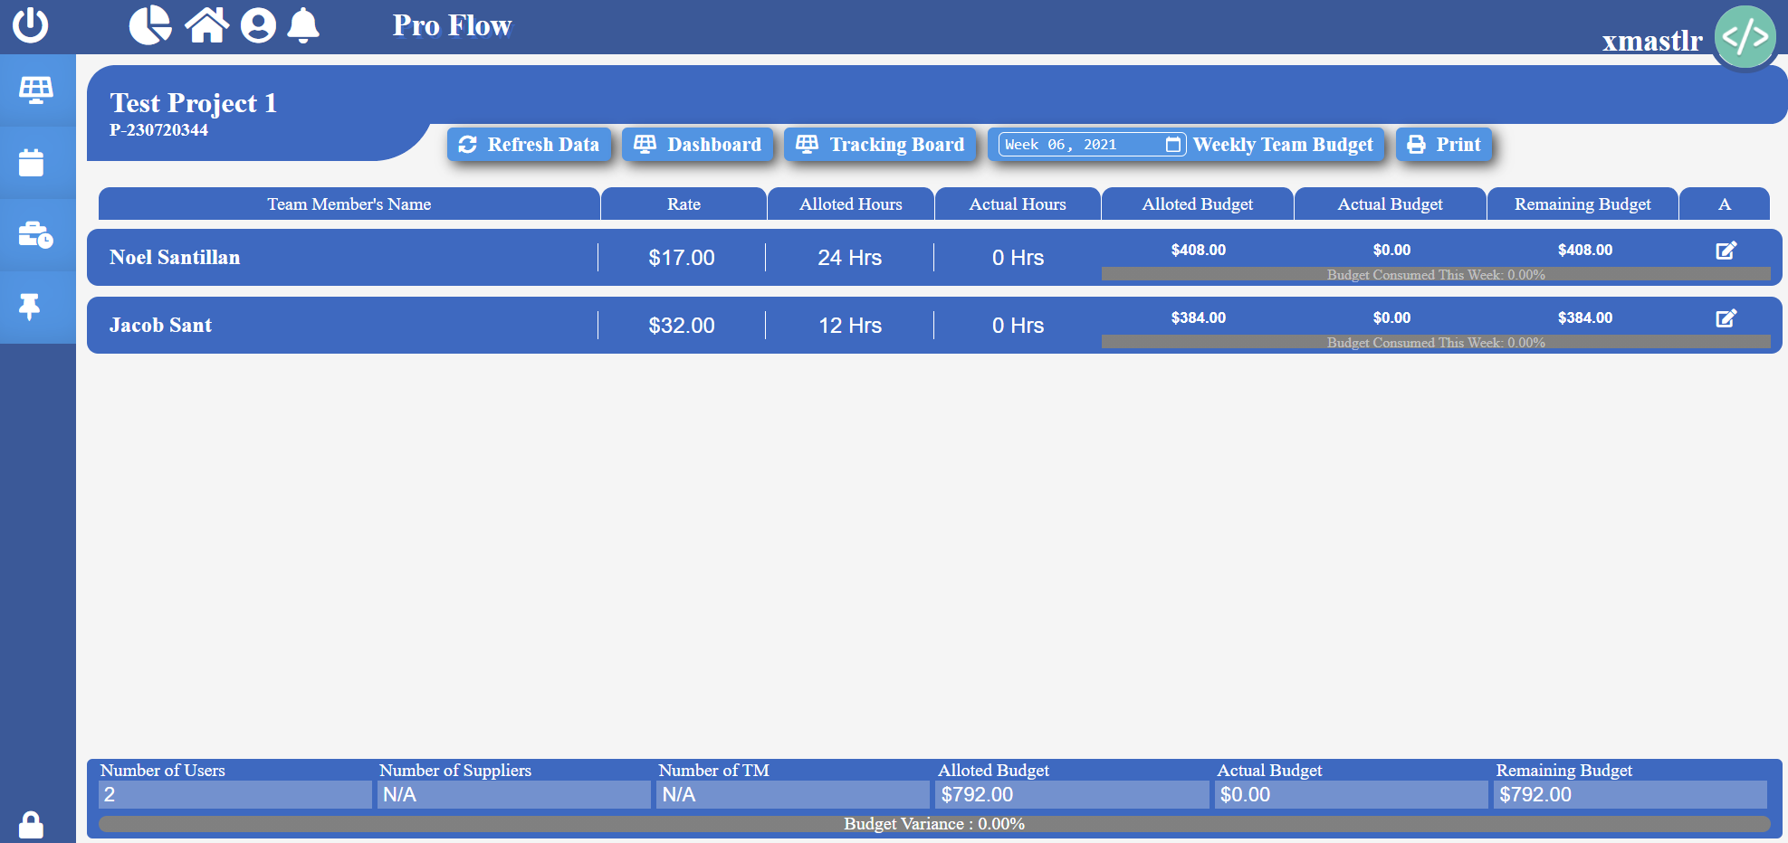

*Track Resource Budget:* In the tracking board, all the resources will be listed by default with the budgeting information.

*View Weekly Team Budget:* Select a week on the “Weekly Team Budget” section to view weekly budget information for all the project resources.

**Spending Board**

**Pro Flow > Active Projects**

To get to spending board, select a project, found on the Active Projects page, then click “Finance” tab on the top of the page. Then click on “Spending” option from the drop-down list.

**Note:** Spending Board is only accessible by project managers and supervisors.

***Spending Dashboard***

*View Budget Items:* In the spending board, click the “Spend Tacking Dashboard” tab found on the top of the page. All the budget items for the project will be listed by default.

*Add Budget Item Invoice:* Click  icon to upload invoice for the budget item of your choice.

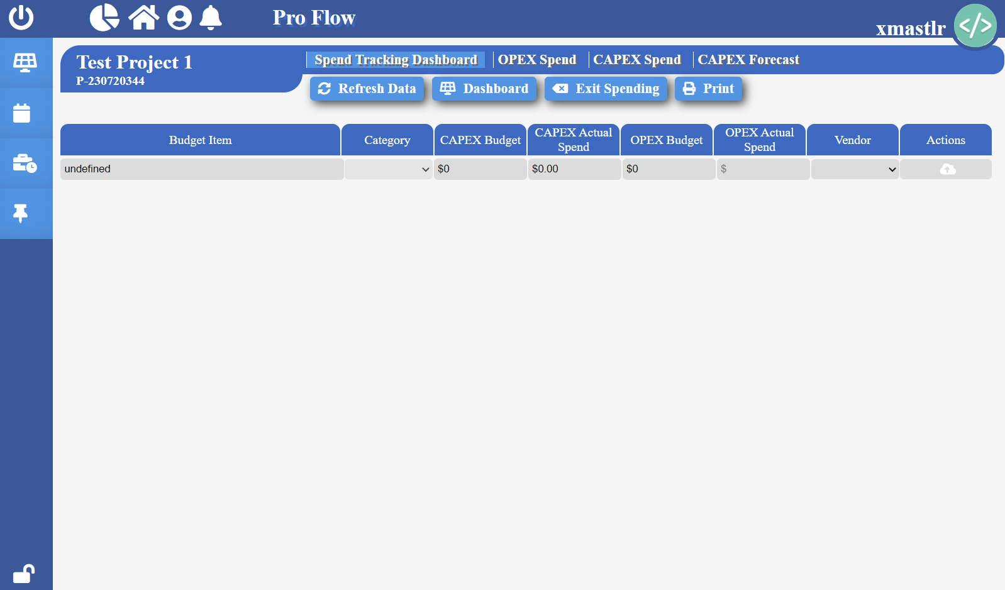

***OPEX Spend***

*View Company Users:* In the spending board, click the “OPEX Spend” tab found on the top of the page. All the company users for the project will be listed by default.

***CAPEX Spend***

*View Company Suppliers:* In the spending board, click the “CAPEX Spend” tab found on the top of the page. All the company suppliers for the project will be listed by default.

*Add Supplier Details:* In the spending board, click “Add Rows” button, provide necessary details about the supplier then click  icon to save changes.

*Create Company Supplier:* In the spending board, click “Create Supplier” button, enter the supplier name, then click “Add Supplier”.

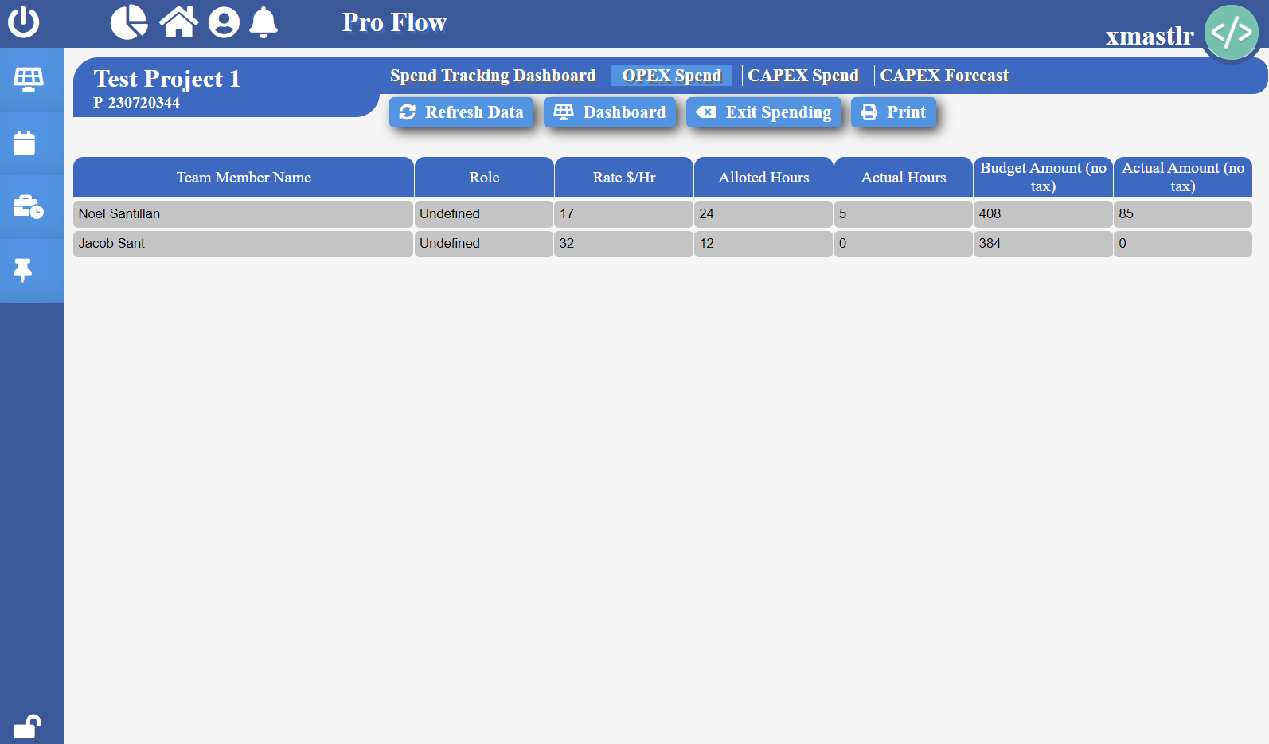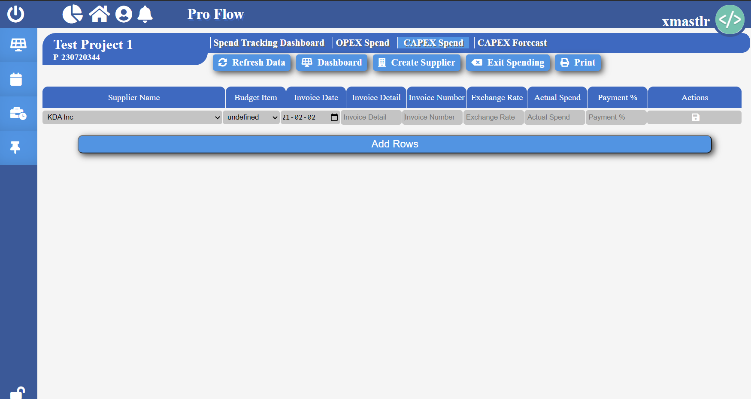

**Build Project**

**Pro Flow > New Projects**

New Projects is a tab on the navigation where a user can create a new project, build a new project in detail, send/receive project request, and share project.

A project can only be created through “Project Create” tab found inside New Projects page.

To get to New Projects page, click  icon found in the navigation on the left side.

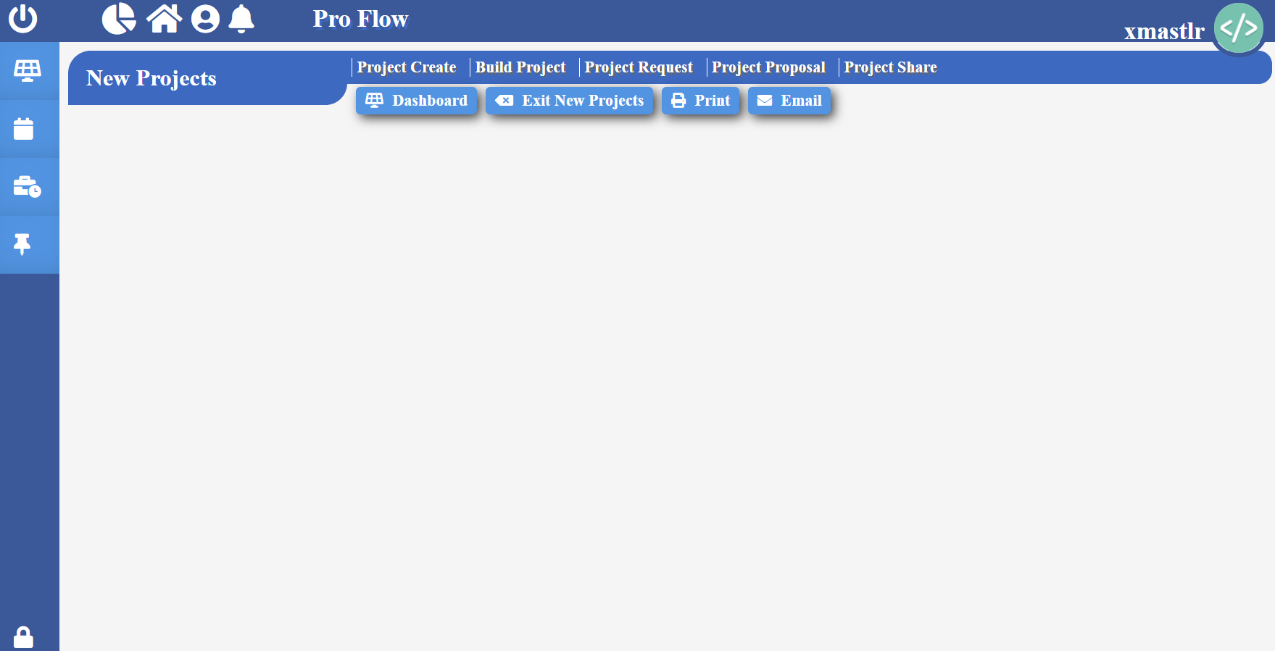

**Project Create**

**Pro Flow > New Projects**

To create a new project, click “Project Create” label found on the top of the New Project page.

Project ID and Project Name are required information needed to successfully create a new project

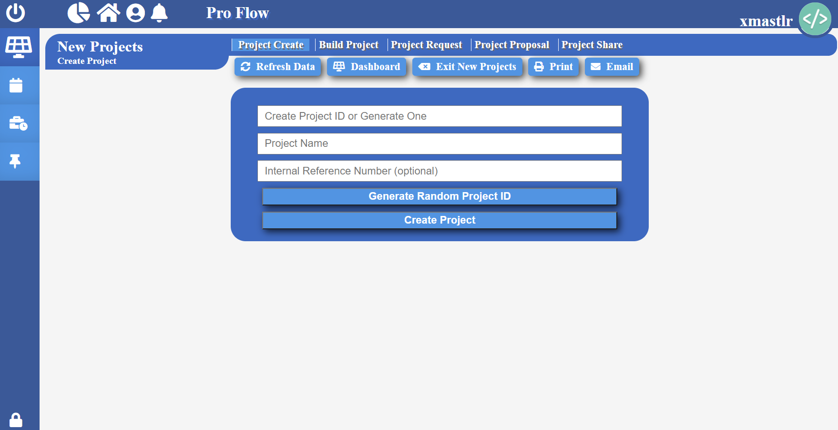

***Create Project:***Fill required project information, then click “Create Project” button.

***Generate Random Project ID:***Click “Generate Random Project ID” found on the project page to create a system generated project ID.

**Build Project**

**Pro Flow > New Projects**

To build a new project, click “Project Build” label found on the top of the New Project page.

A project MUST be already created through “Project Create” tab found inside New Projects page before building a project.

A project needs to be built using create tool found inside “Build Project” tab found inside New Project page.

To get to “Build Project” tab, click on the “Build Project” label found on the top of the New Project page.

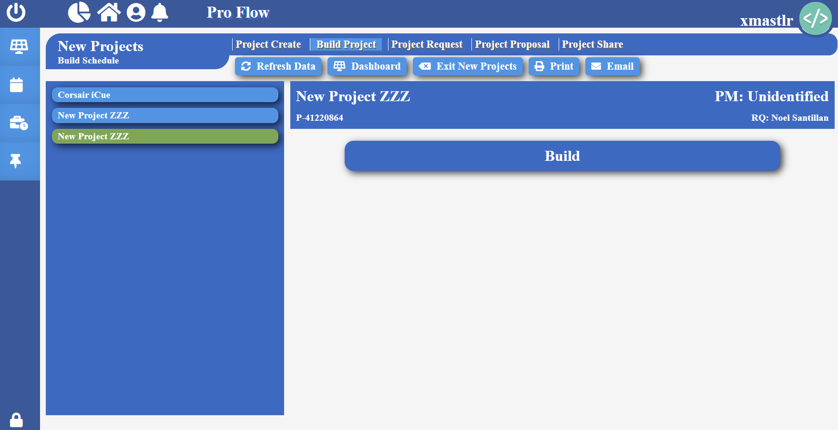

***Build Project:***Select a project, then click “Build” button. This will bring up the create tool.

**Build Project > Create Tool**

**Pro Flow > New Projects**

The project must be sent for approval after filling its technical and schedule information. Once the approval has been received, its budget and financial information can be filled.

Project Manager and Requestor can only be assigned to a user that the project is shared with.

Fill necessary information about the project as shown below.

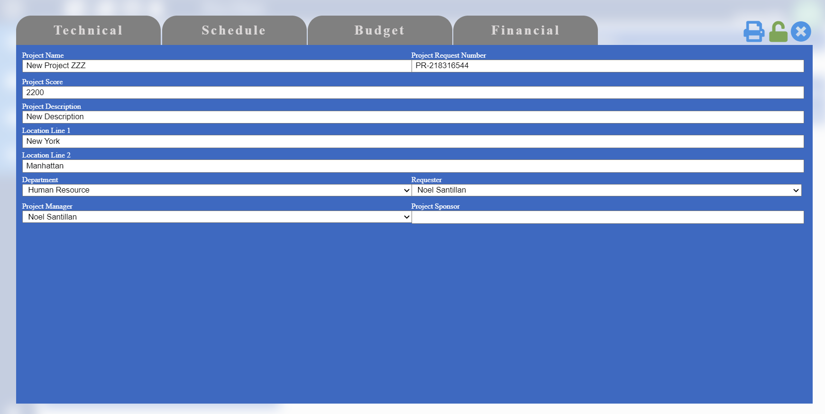

**Create Tool > Fill Technical**

**Pro Flow > New Projects**

To fill technical information about the project, click “Technical” tab found on the top of the create tool.

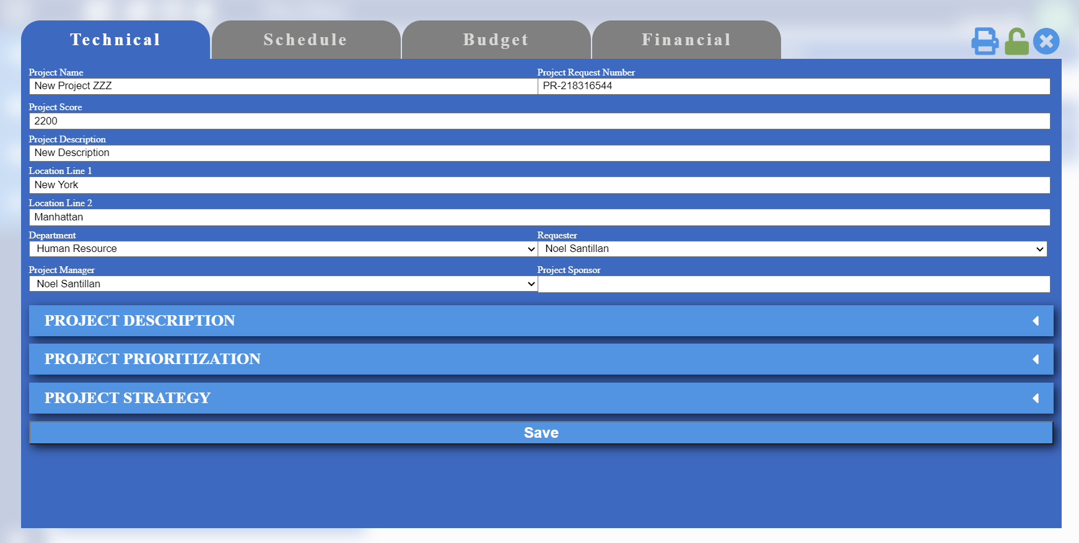

***Project Description:*** Click “PROJECT DESCRIPTION” folder found on the technical tab in create tool to view all the project descripts. Click on the project description of your choice to view more information.

***Custom Description:***Click “Add Row” button inside “PROJECT DESCRIPTION” folder, and type description name.

***Project Prioritization:*** Click “PROJECT PRIORITIZATION” folder found on the technical tab in create tool to view all the project prioritizations. Click on the project description of your choice to view more information.

***Custom Prioritization:***Click “Add Row” button inside “PROJECT PRIORITIZATION” folder, and type prioritization name.

***Project Strategy:*** Click “PROJECT STRATEGY” folder found on the technical tab in create tool to view all the project strategy. Click on the strategy of your choice to view more information.

***Add Strategy:***Click “Add Row” button inside “PROJECT STRATEGY” folder, and type description name.

**Create Tool > Fill Schedule**

**Pro Flow > New Projects**

To create a project schedule, click “Schedule” tab found on the top of the create tool.

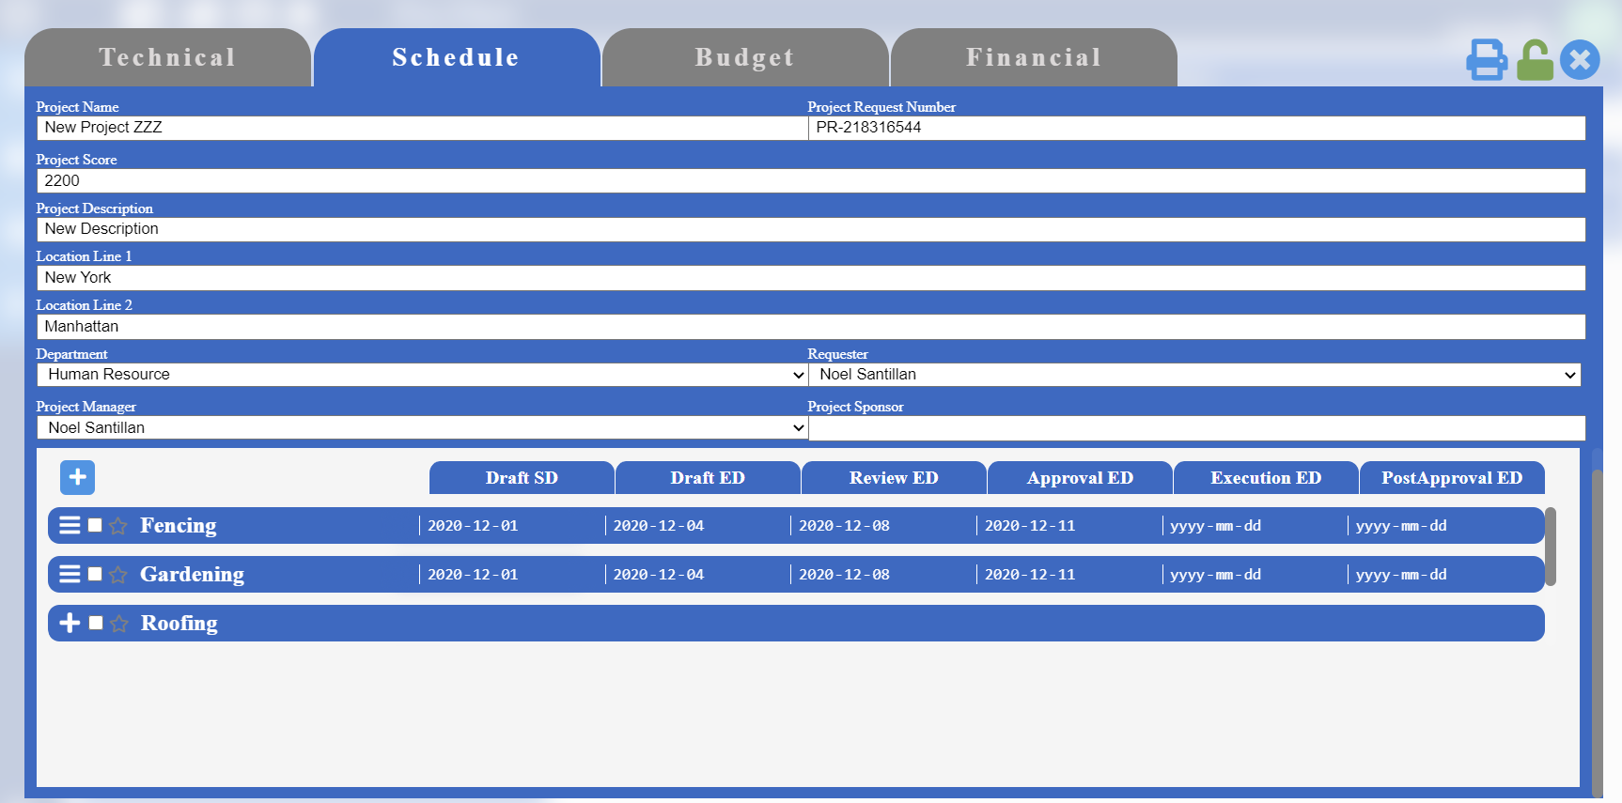

***Create Planning Document:***To create a document plan, click  icon, and fill the require information and then click “Save”. Press “Cancel” to discard document creation.

***Remove Planning Documents:***Click  checkbox for the documents you wish to remove, then click  icon.

***Edit Planning Documents:***Click  checkbox for the documents you wish to edit. Click  icon, make necessary changes then click  icon to save changes.

***View Linked Documents:***Click  checkbox for the document you wish to view links, then click  icon.

***Add Link:***Click  checkbox for the document you wish to link documents to, then click  icon. Select a document stage, then click “Select Stage” button. Then select the document name you wish to link, then click “Add Link” button.

***Remove Linked Document:***Click  checkbox for the any linked document besides the one you want to remove, then click  icon. Then, click  icon on the document you wish to remove from link.

***View Predecessor Documents:***Click  checkbox for the document you wish to view predecessors, then click  icon.

***Add Predecessor:***Click  checkbox for the document you wish to add predecessor, then click  icon. Select a document stage, then click “Select Stage” button. Then select the document name you wish add predecessor as, then click “Add Predecessor” button.

**Pro Flow > New Projects**

***Remove Predecessor Document:***Click  checkbox for the document you want to remove predecessor from, then click  icon. Then, click  icon on the document you wish to remove.

***View Tasks:***Click on the name of the document whose tasks you want to view.

***Create Task:***Click on the name of the document that you want to create the task under. Then click  icon, then fill its necessary information.

***Edit Task:***Click on the name of the document that the task falls under. Then click  icon for the task, then update the information, then click  icon to save the changed information.

***Remove Task:***Click on the name of the document that the task falls under. Then click  icon to remove the task.

***Add Hourly Resource:*** Click on the name of the document that the task falls under. Then click  icon for the task you want to add resource to. Then select “Hourly” as the type of resource, then select the user’s name, assign hours then click “Add Resource” button to complete.

***Add Supplier Resource:*** Click on the name of the document that the task falls under. Then click  icon for the task you want to add resource to. Then select “Supplier” as the type of resource, then select the supplier’s name, then click “Add Resource” button to complete.

***Add T&M Resource:*** Click on the name of the document that the task falls under. Then click  icon for the task you want to add resource to. Then select “T&M” as the type of resource, then select the user’s name, assign hours then click “Add Resource” button to complete.

***Create Temporary Resource:*** Click on the name of the document that the task falls under. Then click  icon for the task you want to add resource to. Then select the type of resource, then write the temporary resource name, then click “Create”.

***Edit Resource:*** Click on the name of the document that the task falls under. Then click  icon for the task you want to remove resource from. Click  icon on the resource you wish to edit, make necessary changes then click  icon to save changes.

***Remove Resource:*** Click on the name of the document that the task falls under. Then click  icon for the task you want to remove resource from. Click  icon on the resource you wish to remove.

***Set Milestone:***Click icon on the document you desire to set as milestone.

**Pro Flow > New Projects**

***Remove Milestone:***Click icon on the document you desire to remove from milestone.

**Create Tool > Fill Budget**

**Pro Flow > New Projects**

To create a project budget, click “Budget” tab found on the top of the create tool.

**Note:** Project’s technical and schedule portion needs to be approved before getting access to the budget tab.

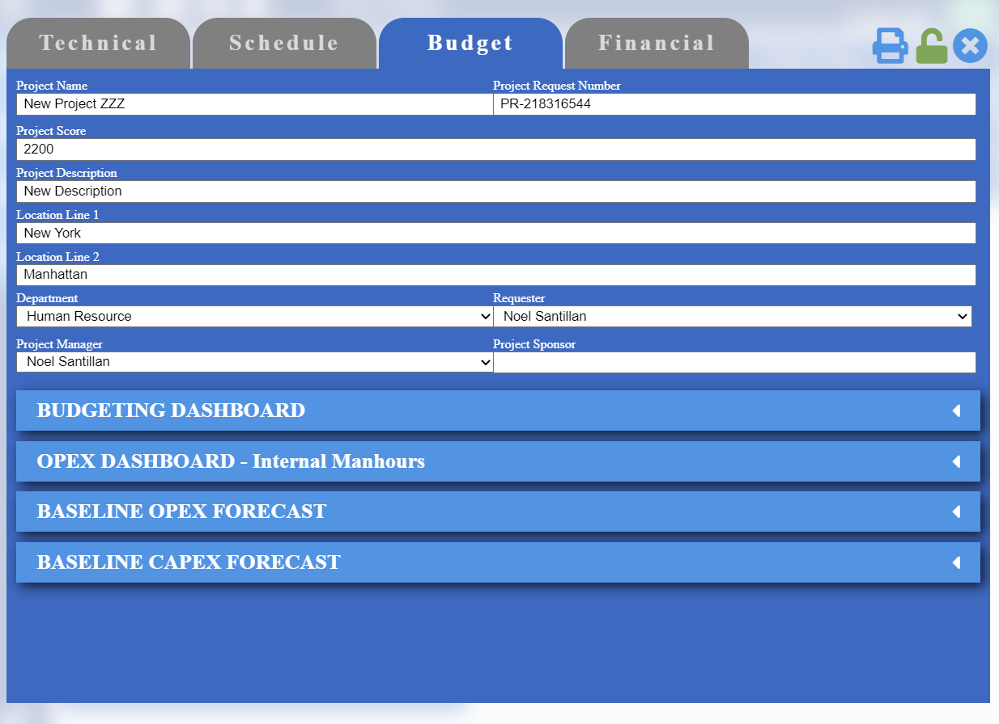

Budgeting Dashboard

*Add Item Category:* Click “Add Item” button found under Budgeting Dashboard tab. Type the name of your new category in the text field named “Add Category”. Then click “Add” button.

*Remove Item Category:* Click “Add Item” button found under Budgeting Dashboard tab. Then click  icon to remove the category of your choice.

*Add Items:* Click “Add Item” button found under Budgeting Dashboard tab. Click on the category your new item falls under, then type item name and item code. Click “Add” button to save the item under that category.

*Remove Items:* Click “Add Item” button found under Budgeting Dashboard tab. Click on the category your new item falls under, then click  to remove the item.

*Add Budgeting Entry:* Click “Add Rows” button located under Budgeting Dashboard. Fill out the required information, then click  icon to save entry.

*Remove Budgeting Entry:* Click  icon on the budgeting entry you wish to remove.

*Upload Invoice/Document:* Click  to upload and save document associated to the budgeting entry.

*Generate Costing:* Click  icon, on the suppliers you wish to expand their budgeting distribution.

OPEX Dashboard

**Pro Flow > New Projects**

Shows all the resources assigned during scheduling phase.

*Update Resource Rate:* Click and open OPEX Dashboard, enter hourly rate then click  icon to save the hourly rate for the resource.

Baseline OPEX Forecast

Shows all the company resources and distribute their budgets throughout chosen year.

*Add Year:* Click and open Baseline OPEX Forecast, click “Add Year” button then choose a year of your choice, then click “Add” button to successfully add a new year.

*Change Monthly to Quarterly:* Select and click on a year, then select “Quarterly” for the view type.

*Change Quarterly Monthly:* Select and click on a year, then select “Monthly” for the view type.

*Distribute Resource Budget:* Select and click on a year, then select and click on a resource, distribute budget, then click “Save” button.

Baseline CAPEX Forecast

Shows all the suppliers and distribute their budgets throughout chosen year.

*Add Year:* Click and open Baseline CAPEX Forecast, click “Add Year” button then choose a year of your choice, then click “Add” button to successfully add a new year.

*Change Monthly to Quarterly:* Select and click on a year, then select “Quarterly” for the view type.

*Change Quarterly Monthly:* Select and click on a year, then select “Monthly” for the view type.

*Distribute Supplier Budget:* Select and click on a year, then select and click on a supplier, distribute budget, then click “Save” button.

**Create Tool > Fill Financial**

**Pro Flow > New Projects**

To view financial details for all the budgeting items, click “Financial” tab found on the top of the create tool.

**Note:** Project’s technical and schedule portion needs to be approved before getting access to the financial tab.

**Note:** Only Project managers can access this financial tab of the project.

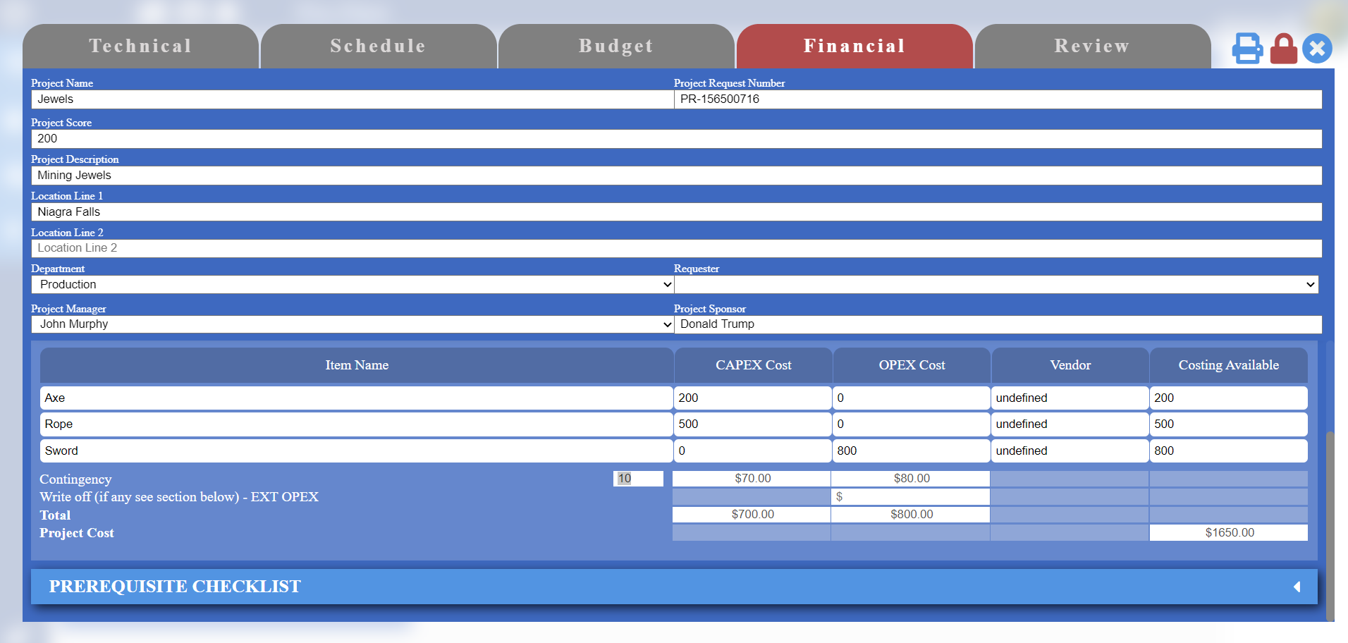

*Change Contingency:* Enter an updated value in the contingency field to change contingency.

**Create Tool > Review Lock**

Review lock functionality allows project managers to review any changes made in the technical and scheduling tabs.

**Note:** Only Project managers can access this review tab of the project.

*Enable/Disable Review Lock:* Click the  icon found on the top right corner of the create tool to enable/disable review lock functionality.

**Note:** Users will be prompted to enter their credentials to verify authority.

**Project Request**

**Pro Flow > New Projects**

To send project request, click “Project Request” label found on the top of the New Project page.

**Note:** The project must be shared with before through “Project Share” tab in New Project page before sending a request to them.

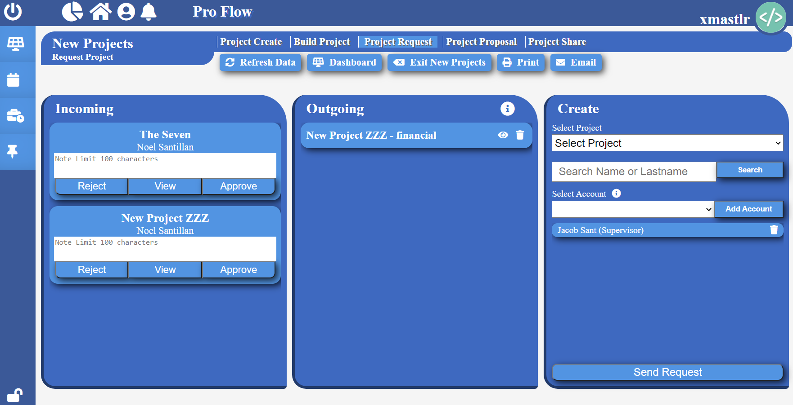

*Send Project Request:* Select project in the “Select Project” tag. Search in the user by first or last name in the search bar, then click “Search” button. Select the user account, then click “Add Account”. Add all the users you want to send request to, then click “Send Request”.

Note: Account supervisor is added by default.

*View Outgoing Request:* Click  icon on the outgoing project request you want to view.

**Note:** The status is color coded. “Yellow” mean request is still pending, “Red” mean request rejected, and Green mean request approved.

*Remove Outgoing Request:* Click  icon on the outgoing project request you want to remove.

*Activate Project:* Click  icon on the outgoing project request you want to make active. Then click “Make Active” button to activate the project.

**Note:** All the users you have sent project rest to must approve before you are able to activate the project.

**Note:** Only project managers can send the project request into financial stage.

*Approve Project Request:* First view the project details by clicking button named “View”. Then click “Approve” button on the incoming project request you want to approve.

**Note:** You can write a custom message to the requestor before approving their project request.

*Reject Project Request:* First view the project details by clicking button named “View”. Briefly explain your reason for rejecting the project, then click “Reject” button on the incoming project request you want to reject.

*View Project Request:* Click “View” button on the incoming project request you want to view.

**Project Share**

**Pro Flow > New Projects**

To share project, click “Project Share” label found on the top of the New Project page.

**Note:** The project must be shared with users before sending project request and assigning them as project manager.

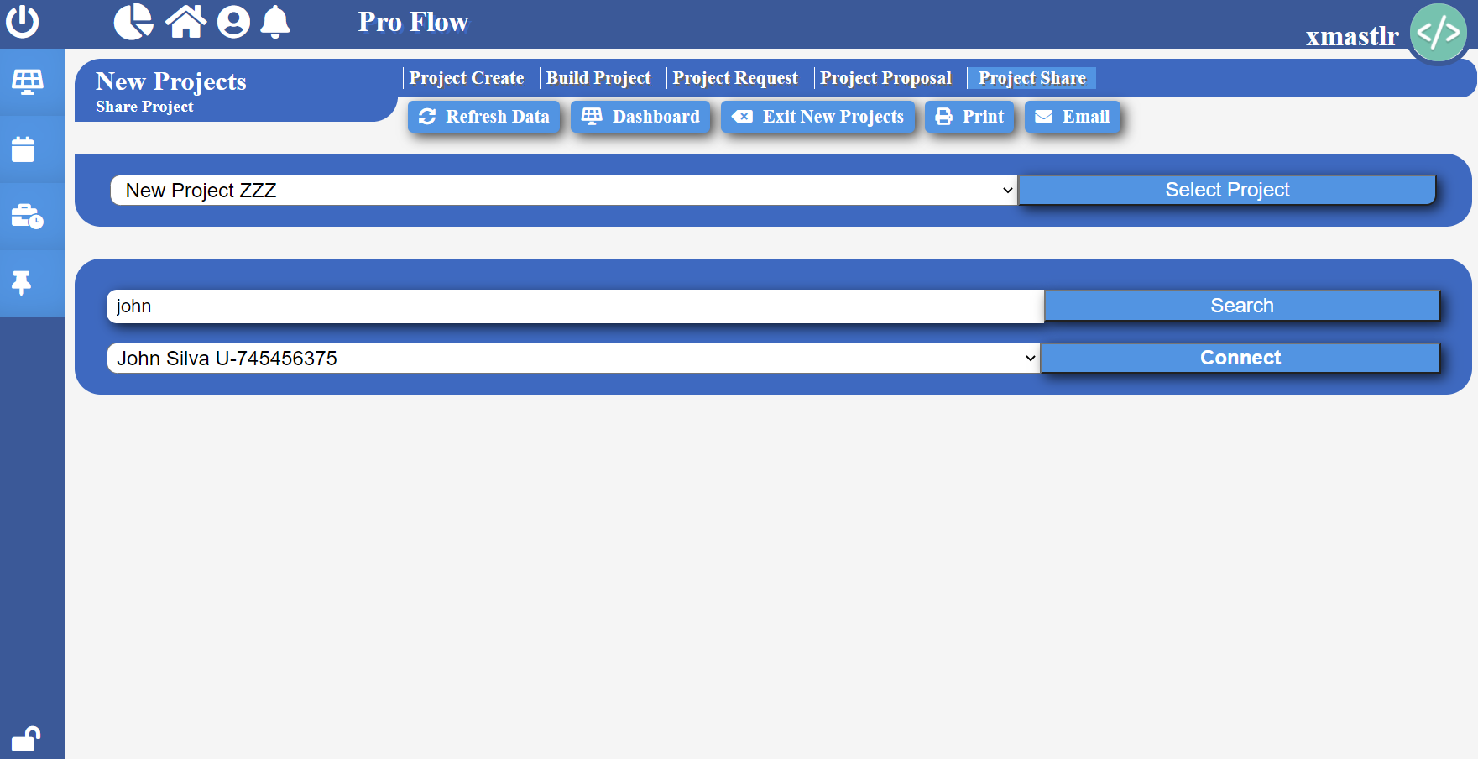

*Share Project:* First select the project you want to share then click “Select Project”. Then search user’s name, click “Search”. Select the user, then click “Connect” to add them to the project.

**Project Time Sheet**

**Pro Flow**

To get to project time sheet, click  icon to open the project time sheet page.

**Note:** All users must enter hours worked on a task from here.

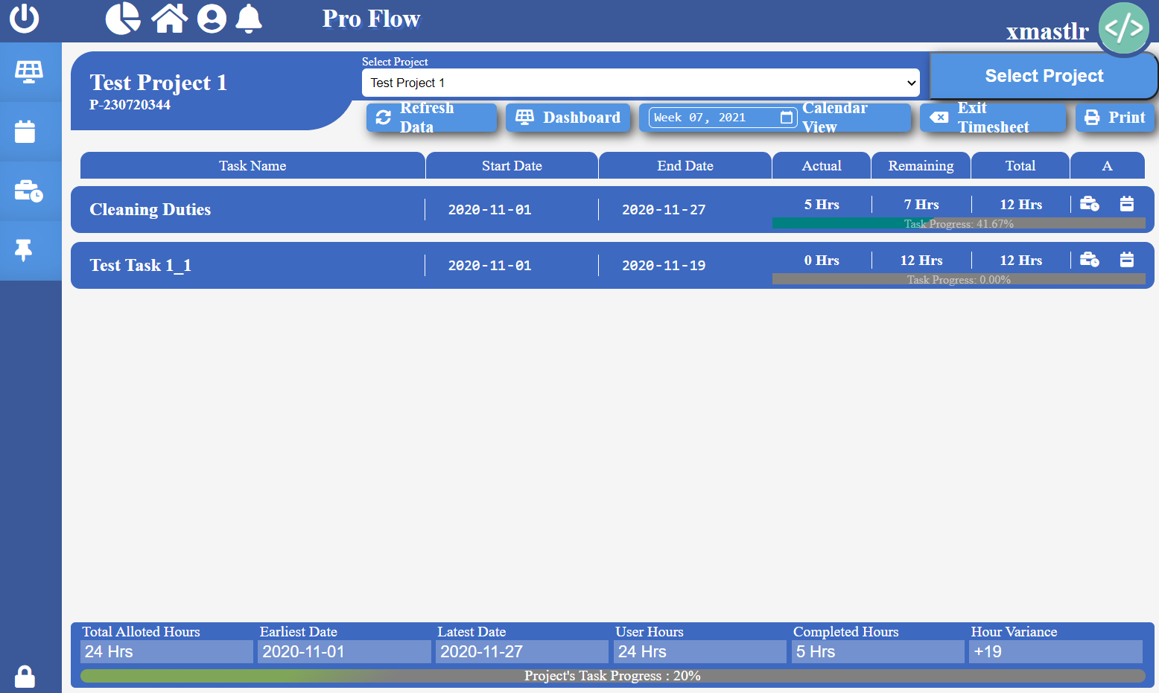

*View Project Tasks:* Select a project of your choice, then click “Select Project” button. All the tasks assigned to you will be listed.

*View Assigned Hours:* Select and click on the task name that you want to view hours.

*Record Worked Hours:* Click  icon on the task of your choice, select the date and total hours you worked on that day, then click  icon to save changes.

*Remove Worked Hour:* Select and click on the task name that you want to view hours. Then click  icon to remove that worked hour.

*Weekly Task Hours:* Click  icon on the task of your choice, to view weekly overview of hours worked on the task.

**My Tasks**

**Pro Flow**

To get to My Task Board, click  icon to open my task board page.

**Note:** All users can come here to view, and track tasks assigned to you.

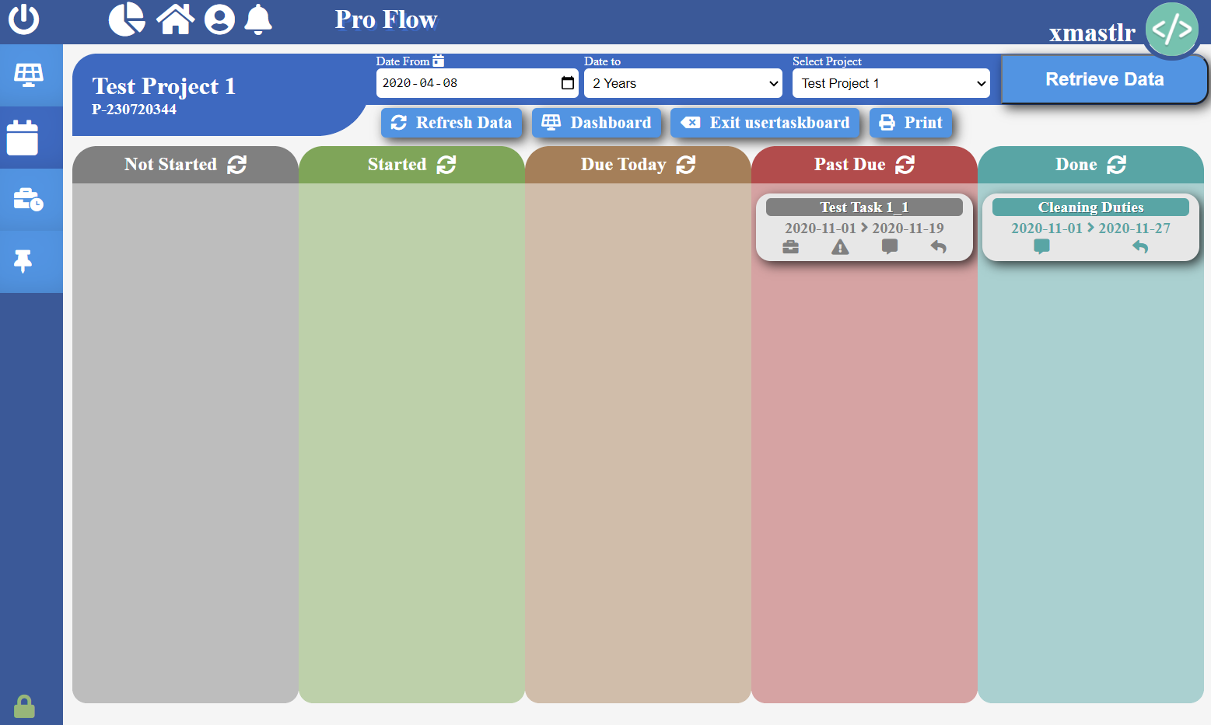

*View Project Tasks:* Select a project of your choice, duration and from date then click “Retrieve Data” button. All the tasks assigned to you will be listed.

*Initiate Task:* Click  icon to indicate you have started working on the task.

*Request Delayed End Date:* Click  icon, then select a end date then click “Send Request” to send a request to change the end date for the task to you project manager.

*Request Task Ownership Change:* Click  icon, then select a team member working on the project then click “Send Request” to send a request to assign the task to another team member instead.

*View PM Message:* Click  icon to see any messages sent from the project manager to you.

*Send Message To PM:* Click  icon and write your message, then click “Send” button to send message to your project manager.

**Skid Builder**

**Skid Builder**

In Skid Builder can be used to design and build skid.

To go to Skid Builder, click on the quick access icon , then select skid builder from the menu. You will then be redirected to the skid builder homepage.

**Note:** Company needs to purchase Skid Builder license or must be enrolled in a free trial to access Skid Builder module.

**Note:** Company admin must provide module access to its users before they can see it in the quick access navigator.

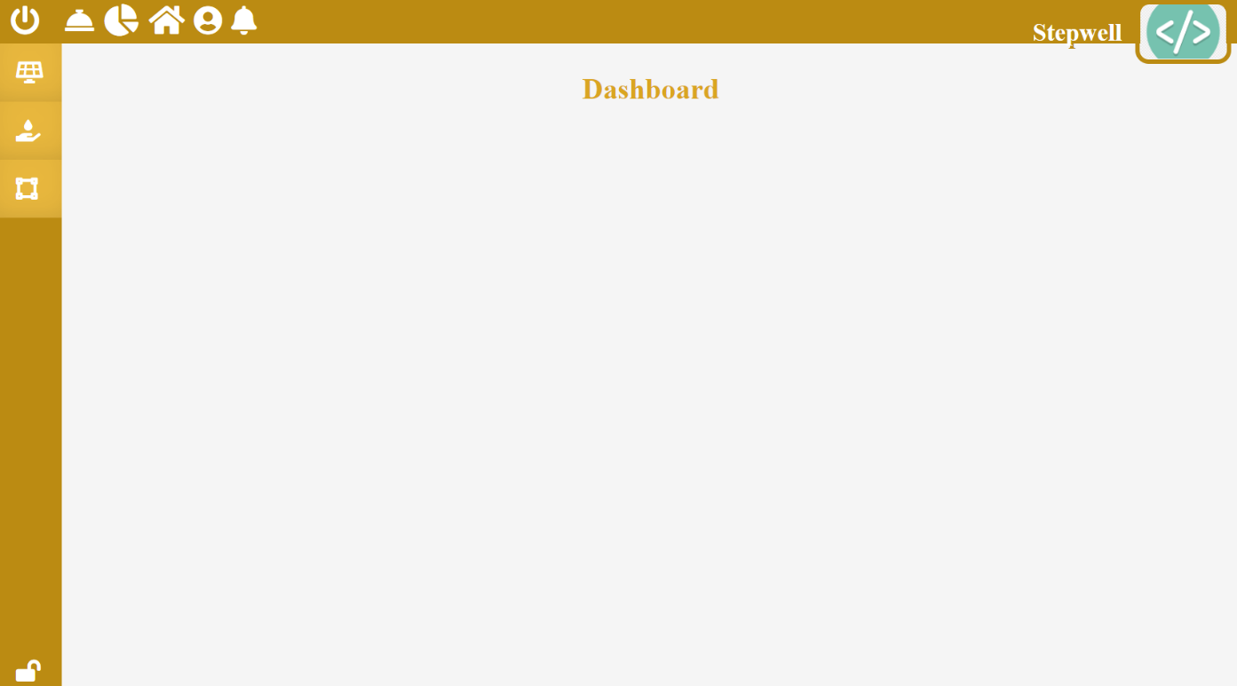

**Skid Builder Dashboard**

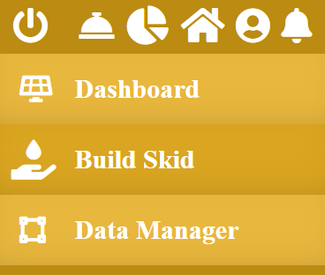**Build Skid**

**Skid Builder**

Here users will be able to design and build multiple skid layouts of their choice. Users will be able to save a copy of the skid layout and be able to resume working in future.

To get here, select “Build Skid” option in the navigation menu.

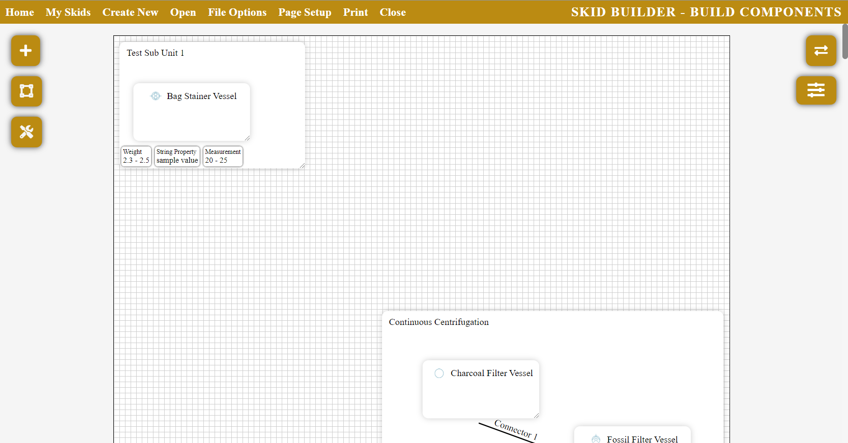

***Return to Skid Builder Home Page:***Simply click on the  icon found on the top navigation bar to

return to skid builder home page.

***Create New Skid:***Simply click on the icon found on the top navigation bar to start

building a new skid.

***View Saved Skids:***Click on the  button to view a complete list of your saved skids. To close

the list, click on the  icon located on the top right corner.

***Open Saved Skid:***Click on the  button, then click on the icon located next to the skid you

want to open.

***Delete Skid:***Click on the  button, then click on the  icon located next to the skid you

want to delete.

***Import Skid File:***Click on the  button, select your desired file, then click “Open” button.

**Note:** The Software only accepts “.ceis” file extension, other file extensions will cause errors.

***Rename Skid:***Click on the  button, type your new skid name in the text field, then click

“Save” button to save changes.

***Download Skid:***Click on the  button then click “Download” button to save a copy of your

skid on your computer.

***Save Skid:***Click on the  button, then click “Save” button to save changes.

***Close Skid:***Click on the  button to close skid. Make sure to save changes before closing skid.

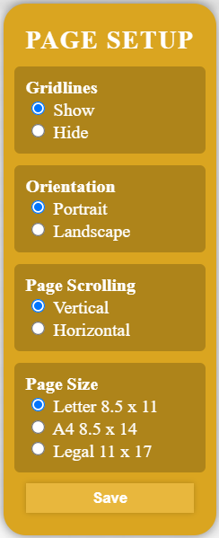**Skid Settings**

**Skid Builder**

***Show/Hide Gridlines:***Click on the  button, select the preferred gridline setting, then click “Save” button to confirm changes.

***Skid Orientation:*** Click on the  button, select the preferred orientation, then click “Save” button to confirm changes.

***Page Scrolling:*** Click on the  button, select the preferred scrolling method, then click “Save” button to confirm changes.

***Page Size:*** Click on the  button, select the preferred page size, then click “Save” button to confirm changes.

***Print Skid:***Simply click on the icon found on the top navigation bar, confirm your print settings then click “Print” button.

**Note:** Confirm and match the page size and orientation to one selected in skid “Page Setup”.

**Note:** For optimal printing, following the recommended printing settings.

**Note:** Click “Cancel” button to cancel printing and close the printing window.

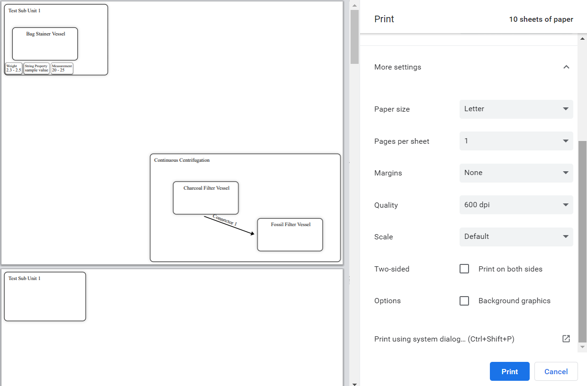

**Recommended Printing Settings**

Set the following settings as provided for optimal printing experience. These setting can be found under “More Settings” tab while printing. The settings are as followed:

*Margins: None*

*Scale: Default*

*Background graphics: Deselected*

**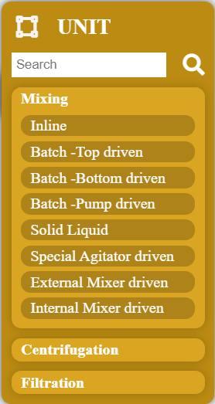*Units:***All the company units can be found by clicking on the  icon.

**Skid Builder**

***Search Units:***Simply enter the unit name or the sub unit name in

the serch bar, then click  icon to retrieve a specific unit/sub unit.

**Note:** Only the sub units can be dropped to the building area.

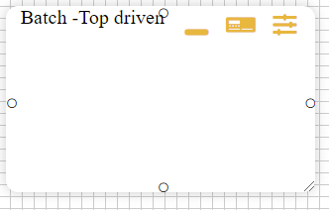

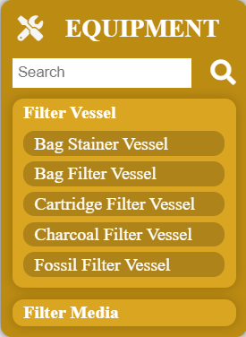 ***Equipment:***All the company equipment can be found by clicking on the 

icon.

***Search Equipment:***Simply enter the equipment name or the sub

equipment name in the serch bar, then click  icon to retrieve a specific equipment /sub equipment.

**Note:** Only the sub equipment can be dropped into sub-units inside

the building area.

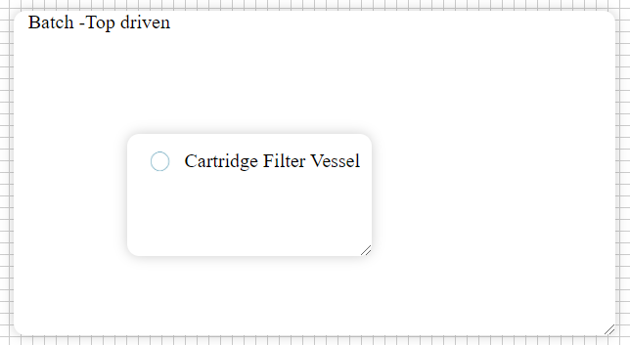

***Skid Building Area****:* Here you can drop multiple sub-units and multiple sub-equipment within those sub-units and build your desired skid.

***Resize Blocks:***To resize, simply hover over  icon, then click and drag to your desired size.

**Note:** Resize icon can found in the bottom right corner of all sub-units and sub-equipment inside the building area.

***Minimize Sub-Units:***Click on the  icon found on the top right corner of all sub-units inside the building area.

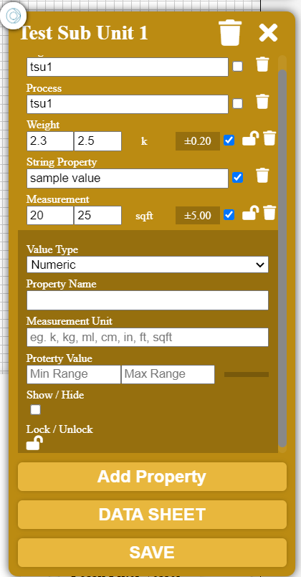***View/Change Sub-Unit Properties:***Click on the icon found on the top right corner of all sub-units inside the building area to view its properties.

**Skid Builder**

***Add Property:***To add your own custom parameter, click the “Add Parameter” button found in the sub-unit properties view. Enter the information of your new parameter, then click “SAVE” button to save changes.

***Show Property:*** In the property view area of your sub-units, select the check boxes of the properties you wish to display in the building area.

***Hide Property:*** In the property view area of your sub-units, select the uncheck boxes of the properties you wish to hide in the building area.

***Lock/Unlock Property:*** Click on the  icon found on the property view area of a sub-unit to lock or unlock the parameter.

***Remove Sub-Uni Property:*** Click on the  icon found on the property view area of a sub-unit to remove it from the building area.

***View/Change Sub-Equipment Properties:***Click on the sub-equipmentinside the building area to view its properties.

***Add Property:***To add your own custom parameter, click the “Add Parameter” button found in the sub-equipmentproperties view. Enter the information of your new parameter, then click “SAVE” button to save changes.

***Show Property:*** In the property view area of your sub-equipment, select the check boxes of the properties you wish to display in the building area.

***Hide Property:*** In the property view area of your sub- equipment, select the uncheck boxes of the properties you wish to hide in the building area.

***Lock/Unlock Property:*** Click on the  icon found on the property view area of a sub-equipment to lock or unlock the parameter.

***Remove Sub-Equipment Property:*** Click on the  icon found on the property view area of a sub-equipment to remove it from the building area.

***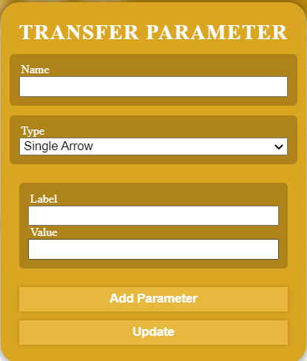*Transfer Parameter**

***Add Transfer Parameter:*** First click a connector found on the equipment or a unit. Then click on another connector you want to connect to. Then enter name of your transfer parameter, select the type of arrow (single or double). Then click “Save” button to make changes.

**Note:** Connectors will be displayed once you hover your cursor on units/equipment.

***Update Transfer Parameter:*** Click on the transfer parameter you want to update, make necessary changes, then click “Update” button to save changes.

***Add Transfer Parameter Property:*** Click on the transfer parameter you want to add properties to. Click “Add Parameter” button. Enter the name of your parameter and its value. Then click “Update” button.

**Data Comparison**

**Skid Builder**

Users can have 2 sets of scale comparisons at once. Here they will also be able to perform simple mathematical operations to set values for specified field.

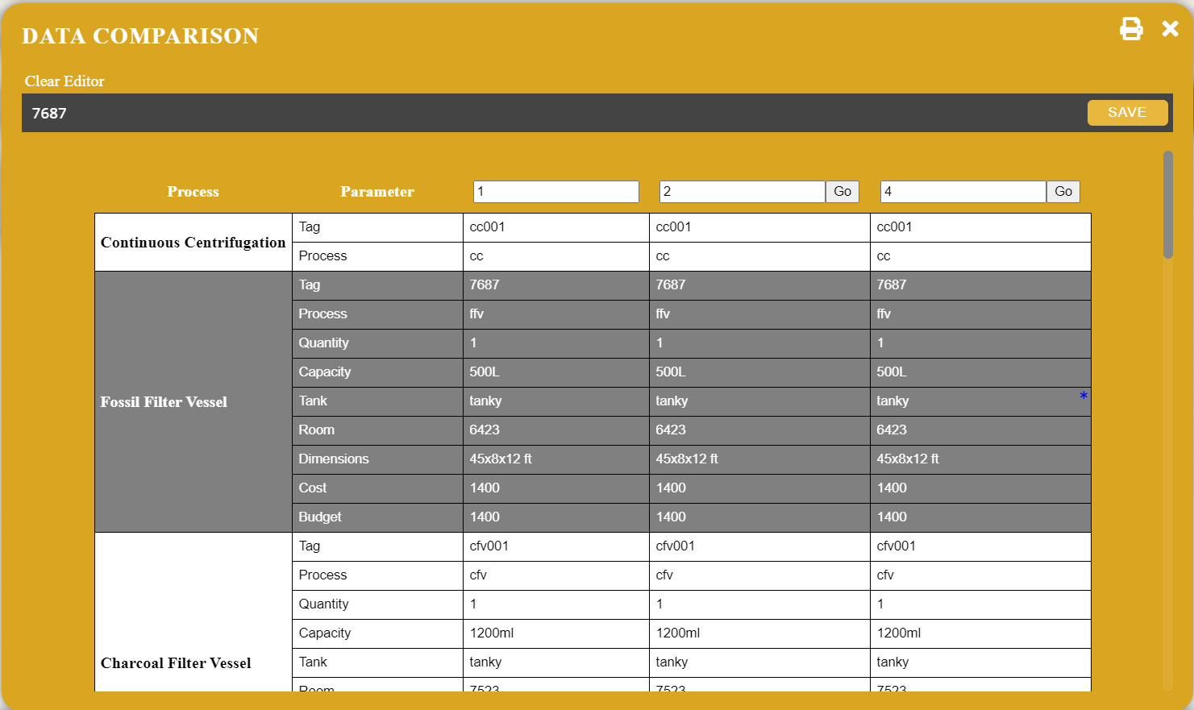

***Print Data:***Simply click on the icon found on the data comparison area, confirm your print settings then click “Print” button.

**Note:** Click “Cancel” button to cancel printing and close the printing window.

***Scale Comparison:*** Simply type the scale factor in the text field in the top, then click “Go” button to view comparisons.

**Formulas**

***View Formula:*** Click on the cell you want to view formula of. It will be shown in the top of the data comparison page.

***Edit Formula:*** Click on the cell you want to change formula of. It will be shown in the top of the data comparison page. Make necessary changes, then click “SAVE” button to save changes.

***Add Formula:*** Click on the cell you want to add formula to. Write your formula in the text field found in the top of the data comparison page, then click “SAVE” button to save changes.

**Types of Formula**

To write a formula, first type the keyword (SUM, SUBTRACT, MULTIPLY, DIVIDE) followed by an open bracket(round). Then select the first cell followed by the second cell. Then end the formula by typing the closing bracket(round).

**Note:** The software will disable keyboard typing once you type the open bracket (round) in the text field.

**Note:** All changed changes will be indicated by icon on the top right of the cell that is updated.

**Data Manager**

**Skid Builder**

Here users can view/update all the Units, Sub-Units, Equipment, Sub-Equipment, and their parameters.

To get here, Select the “Data Manager” tab in the navigation menu.

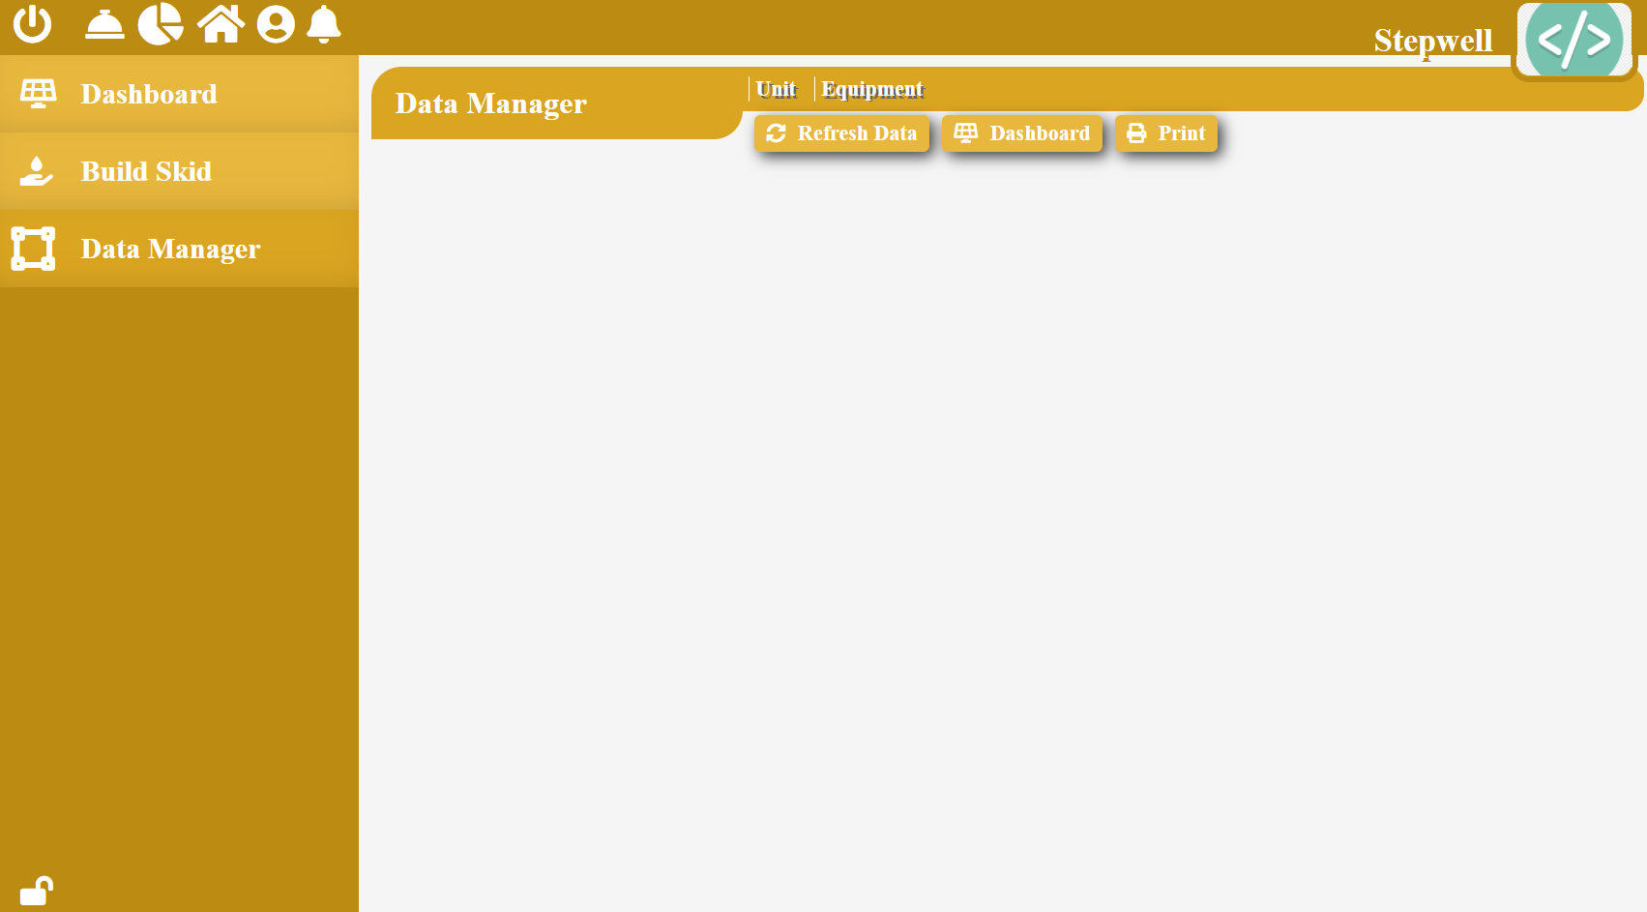

***Refresh Data:***Click “Refresh Data” to fetch and show updated list of Units and Equipment.

***Dashboard:***Click “Dashboard” button to navigate to dashboard of skid builder module.

***Print:***Click “Print” to out a list of all units and equipment.

**Data Manager – Units**

**Skid Builder**

Select Units in the sub-header found on the top of the Data Manager page.

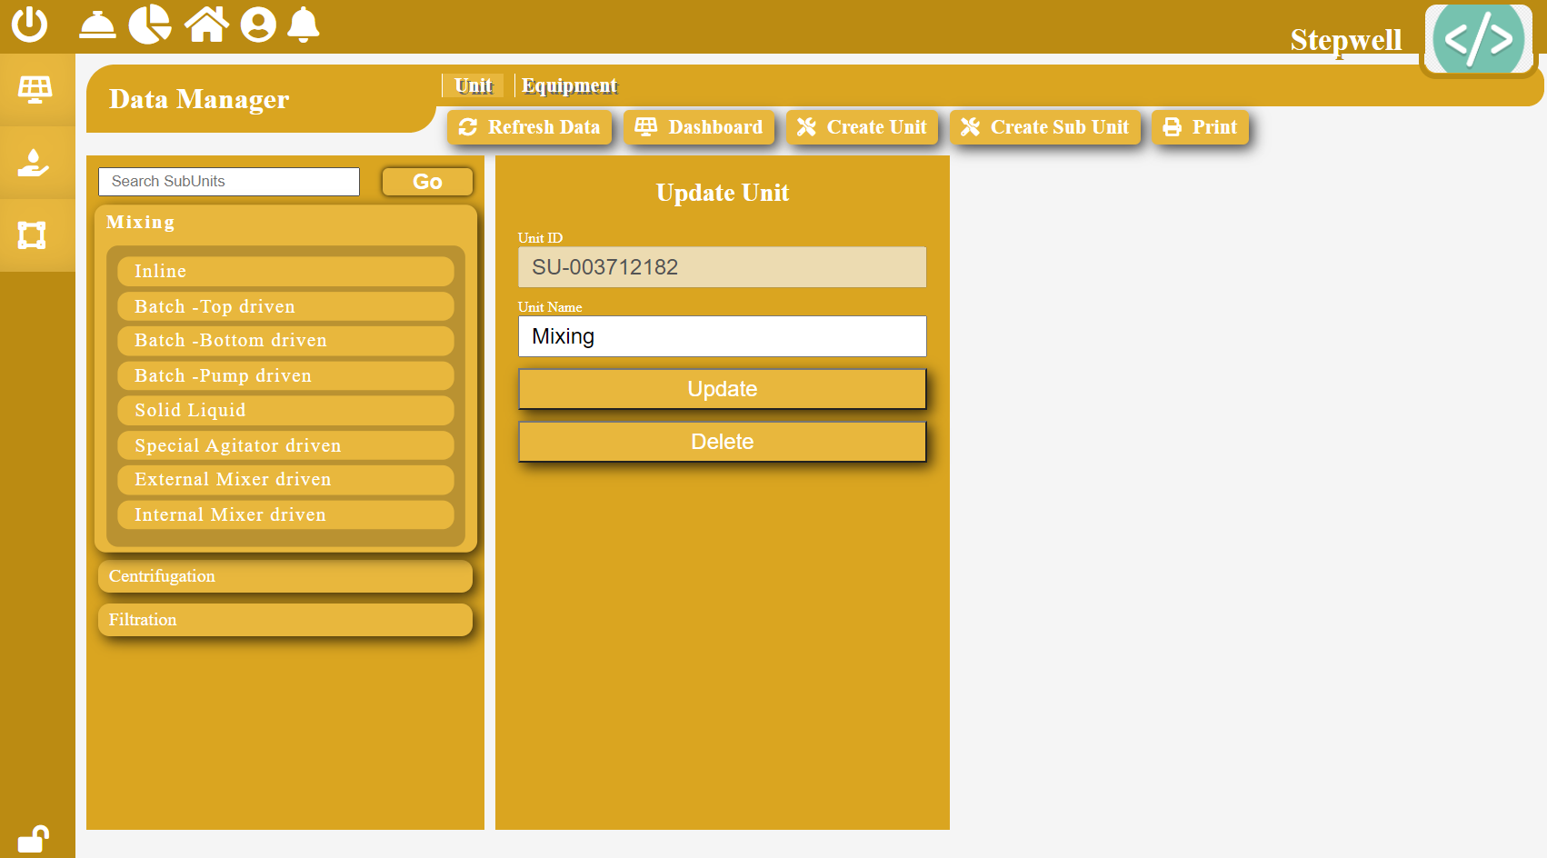

***Search Unit/Sub-Unit:***Enter the name of the unit or a sub-unit in the search bar, then click “Go” button to view the results.

***Update Unit/Sub-Unit:***Select a unit or a sub-unit, make necessary changes, then click “Update” button to save changes.

***Delete Unit/Sub-Unit:***Select a unit or a sub-unit, then click “Delete” button to remove it from the list.

***Create Unit:***Click on the “Create Unit” button found on the top, fill necessary information, then click “Save” button to save changes.

***Create Sub-Unit:***Select a unit, then click on the “Create Sub-Unit” button found on the top, fill necessary information, then click “Save” button to save changes.

**Data Manager – Equipment**

**Skid Builder**

Select Equipment in the sub-header found on the top of the Data Manager page.

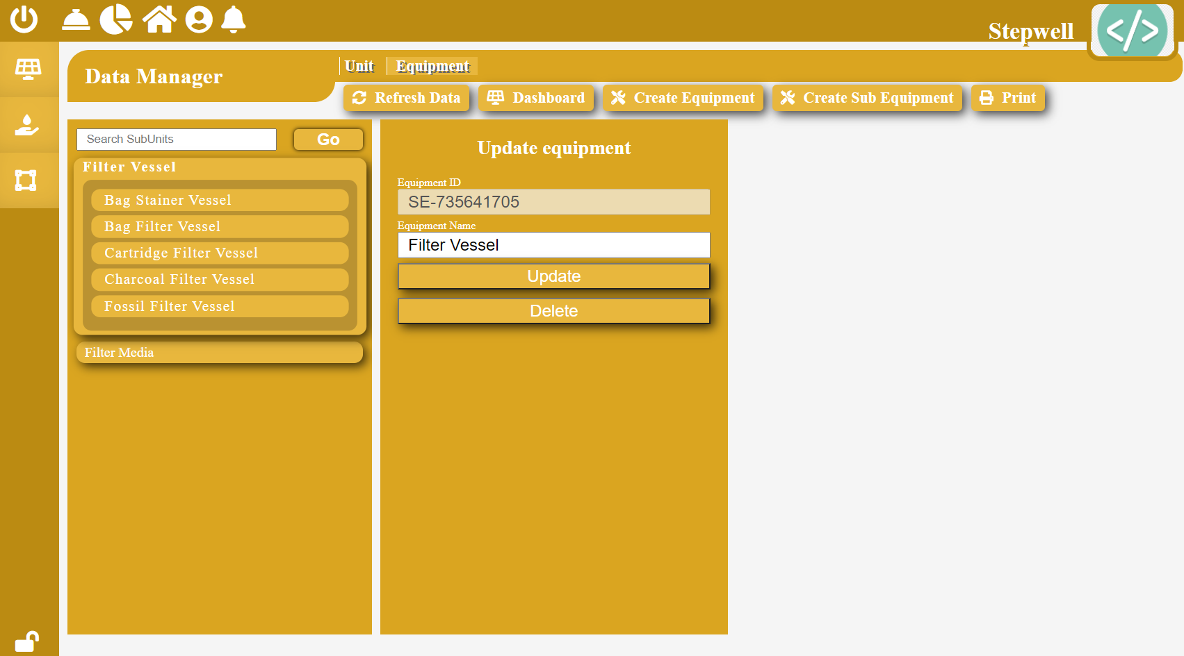

***Search Equipment/Sub-Equipment:***Enter the name of the equipment or a sub-equipment in the search bar, then click “Go” button to view the results.

***Update Equipment/Sub-Equipment:***Select an equipment or a sub-equipment, make necessary changes, then click “Update” button to save changes.

***Delete Equipment/Sub-Equipment:***Select an equipment or a sub- equipment, then click “Delete” button to remove it from the list.

***Create Equipment:***Click on the “Create Equipment” button found on the top, fill necessary information, then click “Save” button to save changes.

***Create Sub-Equipment:***Select an equipment, then click on the “Create Sub-Equipment” button found on the top, fill necessary information, then click “Save” button to save changes.

|  |  |  |  |
| --- | --- | --- | --- |
| Document Version: | __________________ | Document Number: | __________________ |
|  |  |  |  |
| Signature: | __________________ | Date: | __________________ |